***PROJECT REPORT-***

***FIRE ALERT MONITORING SYSTEM***

***GOAL 1: SENDING DATA FROM IOT SENSORS TOAWS IOT.***

***GOAL 2: SENDING DATA FROM AWS IOT TO DYNMODB DATABASE.***

***GOAL 3: MAINTAINING CSV FILE IN S3 BUCKET.***

***GOAL 4: APPLYING MACHINE LEARNING ALGO. THROUGH AWS SAGEMAKER.***

***GOAL 5: ARDUINO CODE.***

***GOAL 1: SENDING DATA FROM IOT SENSORS TO AWS IOT.***

**STEP 1: LOGIN TO AN AWS ACCOUNT.**

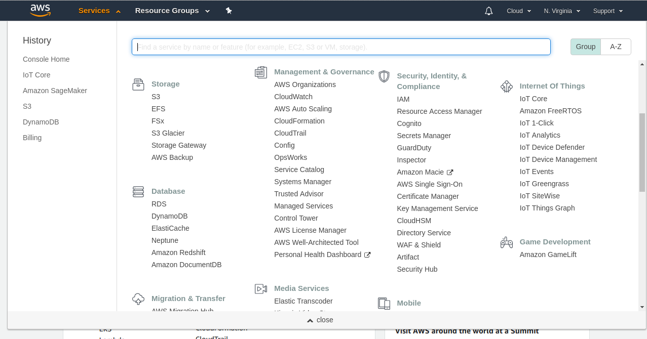

**STEP 2: GO TO AWS IOT CORE.**

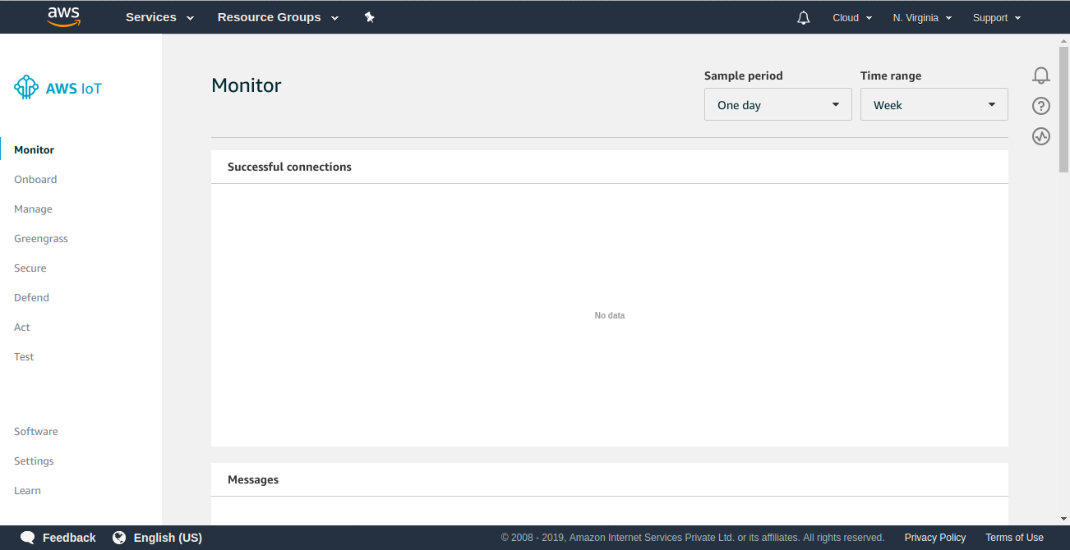

**STEP 3: GO TO MANAGE -> THING AND REGISTER A THING.**

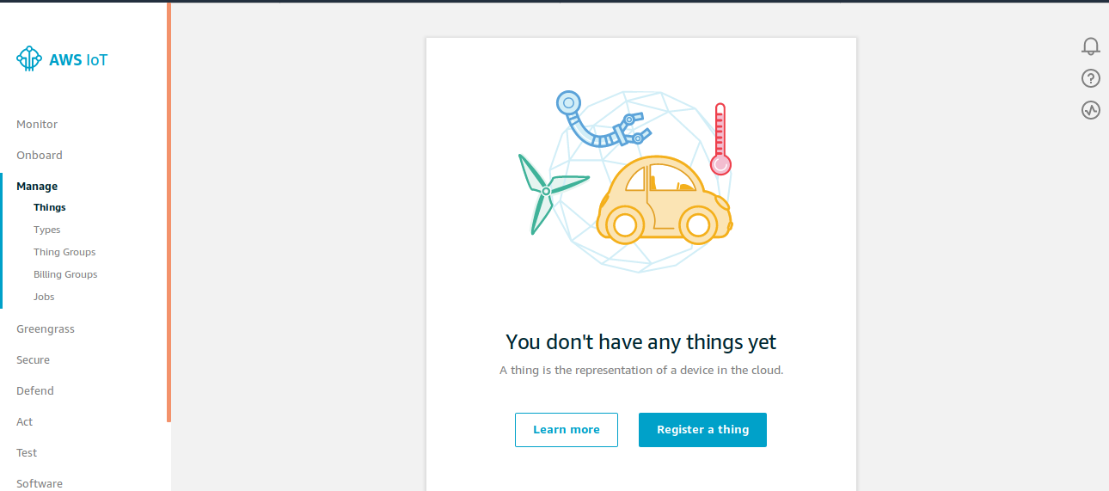

**STEP 4: CREATE A SINGLE THING.**

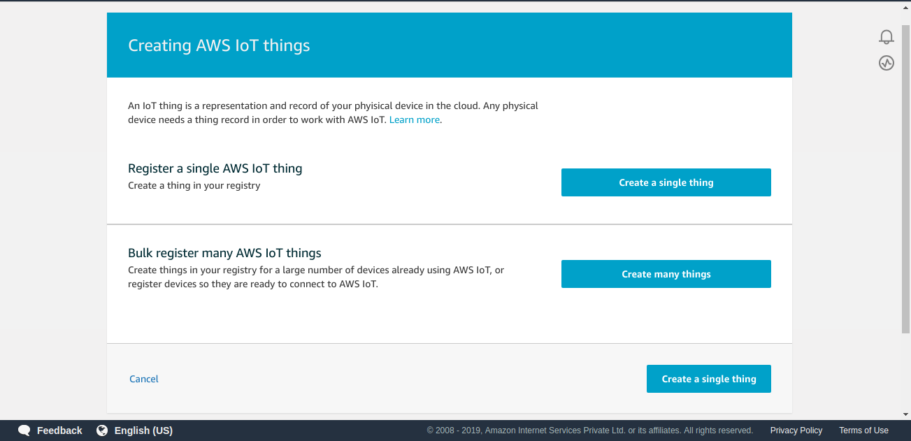

**STEP 5: GIVE THE NAME OF THING TO BE CREATED.**

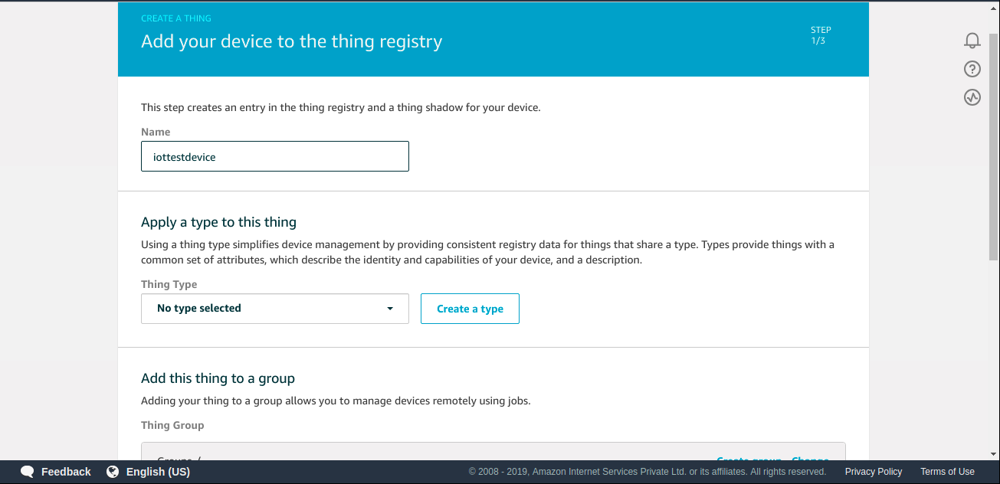

**STEP 6: SELECT THE GROUP AND GO TO NEXT.**

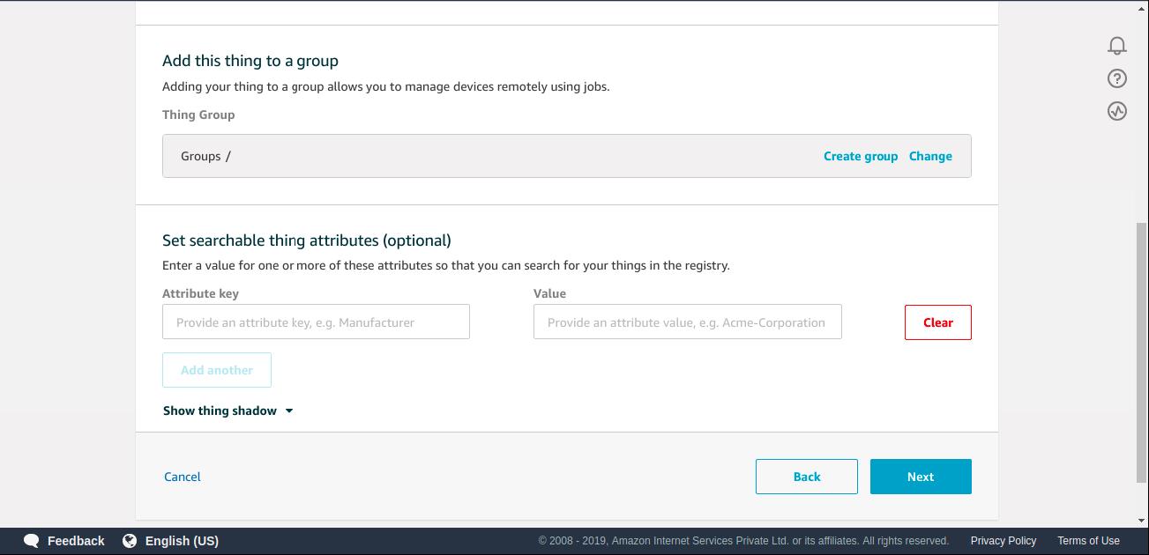

**STEP 7: SELECT CREATE THING WITHOUT SHADOW.**

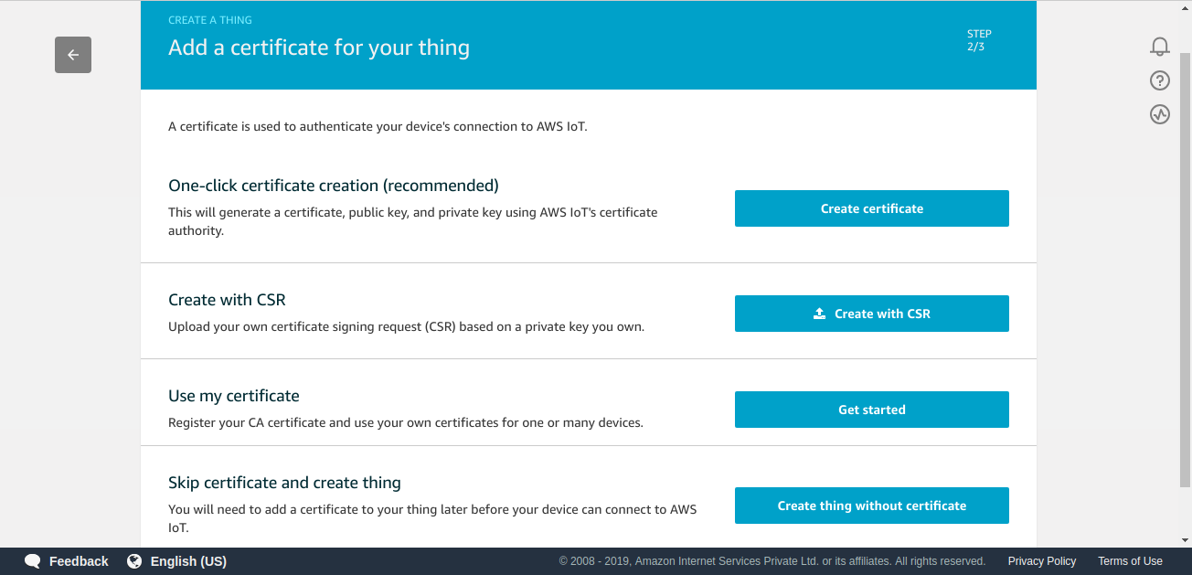

**STEP 8: A THING WILL BE CREATED.**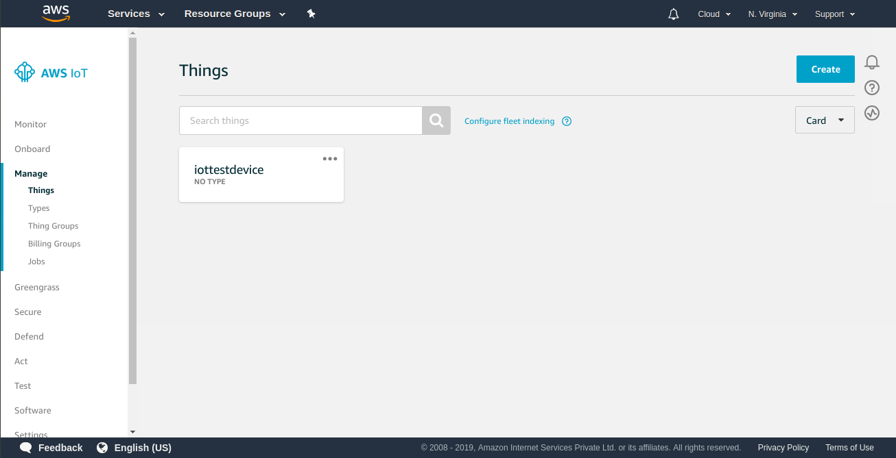

**STEP 9: DETAILS OF THE THING.**

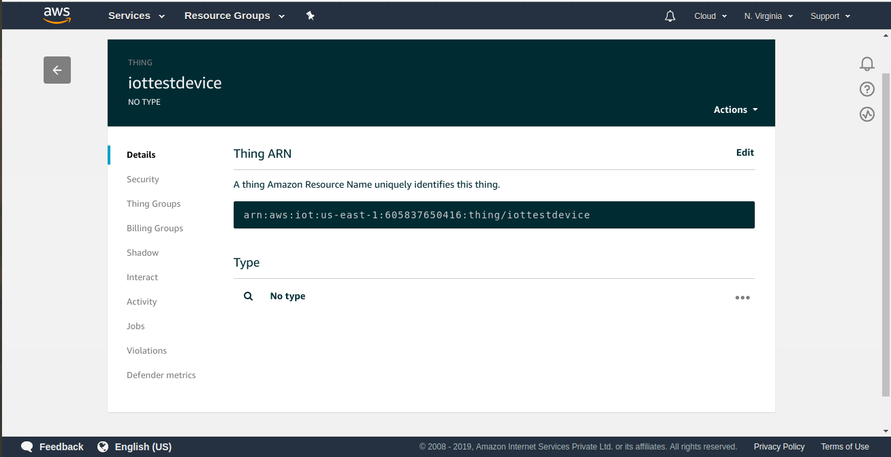

**STEP 10: GO TO INTERACT FOR FURTHER DETAILS.**

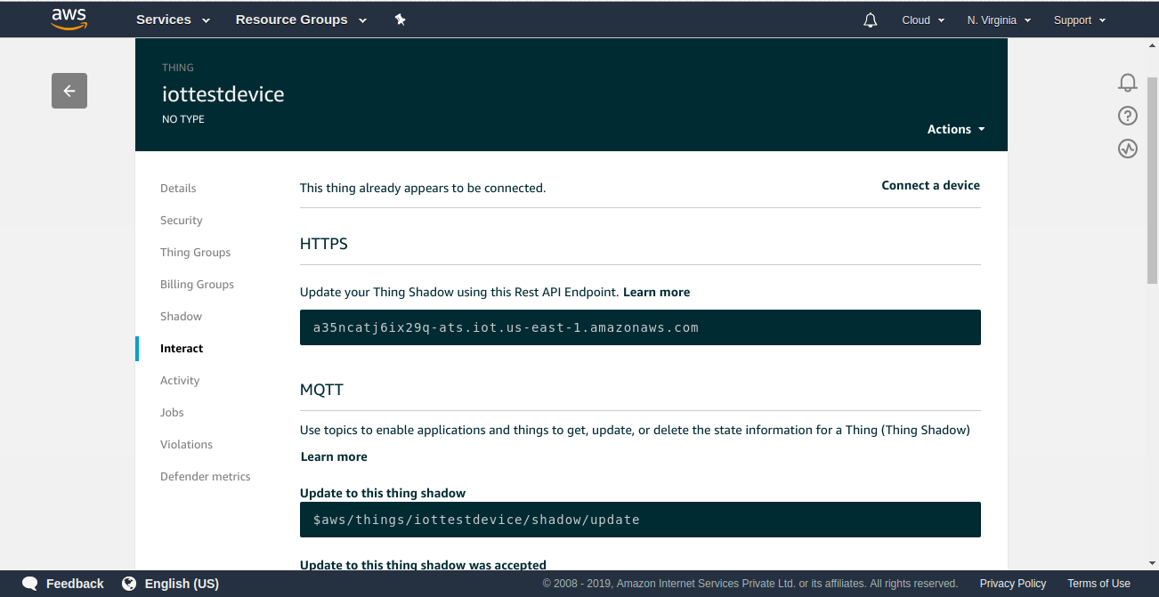

**STEP 11: ALL DETAILS OF SHADOW ARE PRESENT.**

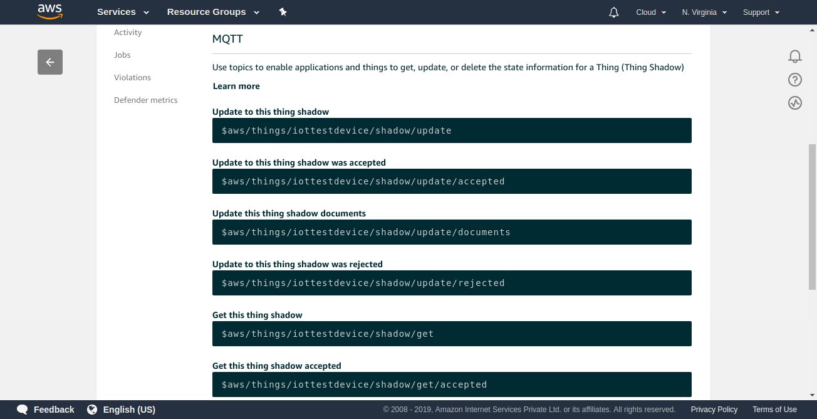

**STEP 12:GO TO SERVICES AND SELECT IAM.** 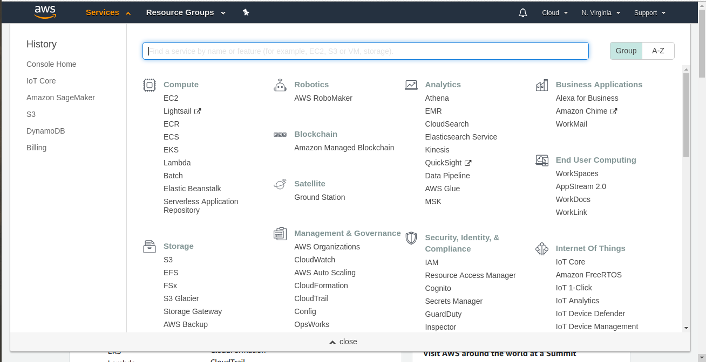

**STEP 13:CREATE A IAM USER .**

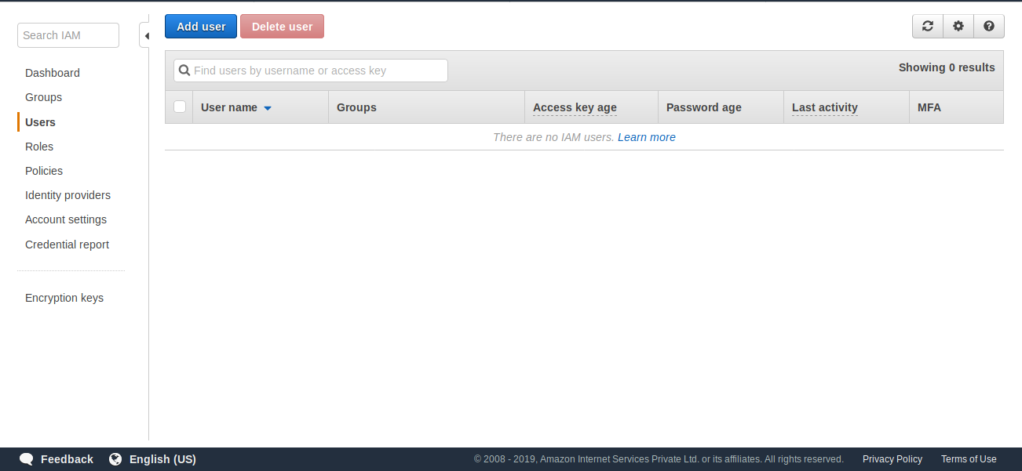

**STEP 14: USER IS CREATED.**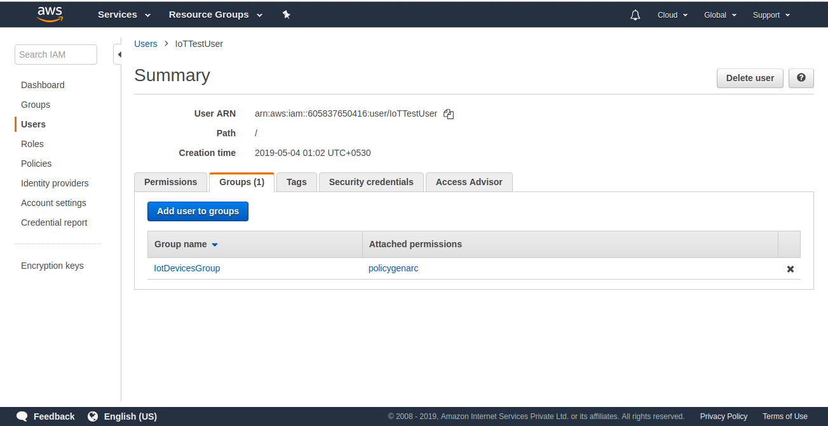

**STEP 15: CREATE IAM GROUP**

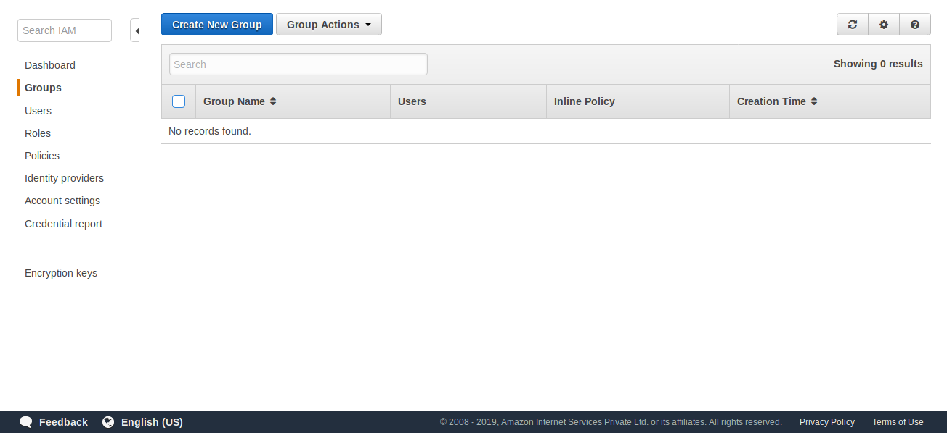

**STEP 16: IAM GROUP IS CREATED.**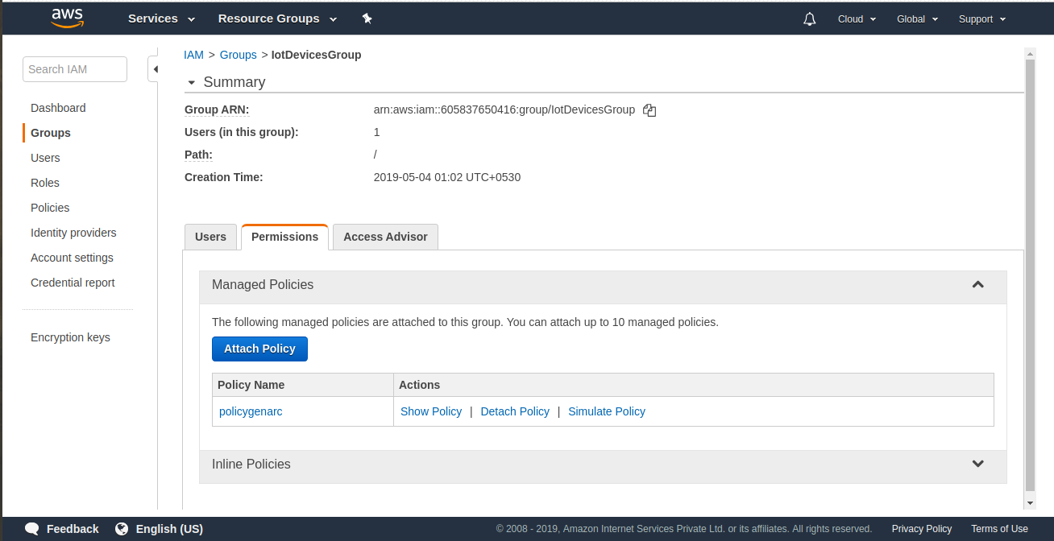

**STEP 17:CREATE IAM POLICY.**

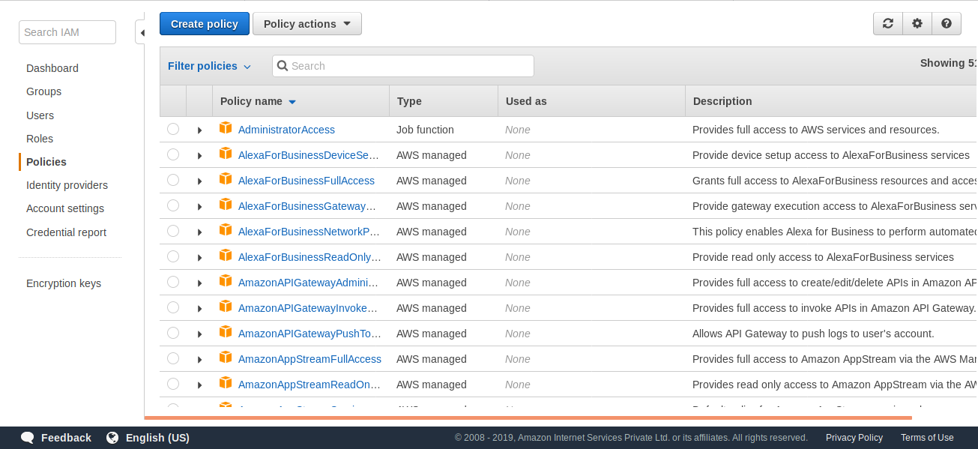

**STEP 18: IAM POLICY IS CREATED.**

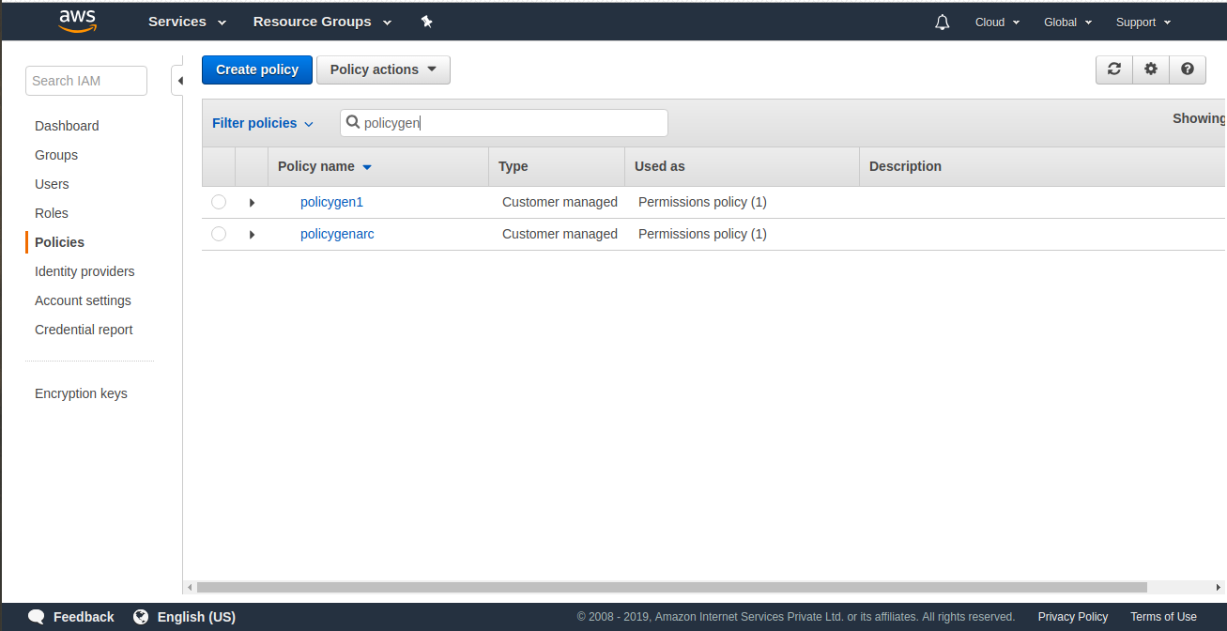

**STEP 19: UPDATE THE CODE ACCORDINGLY.**

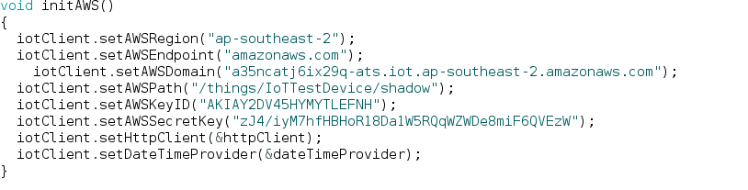

**STEP 20:RUN THE CODE AND MONITOR SHADOW STATE OF IOT CORE.**

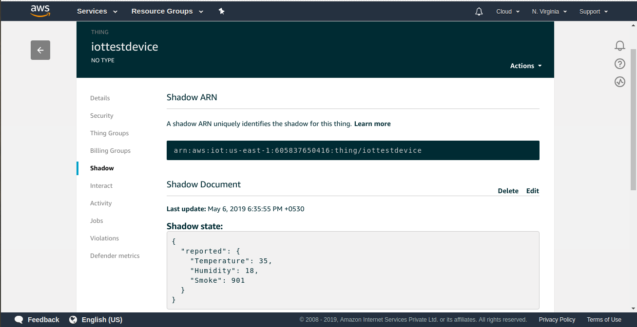

**STEP 21: CHECK THE METADATA FOR FURTHER INFO.**

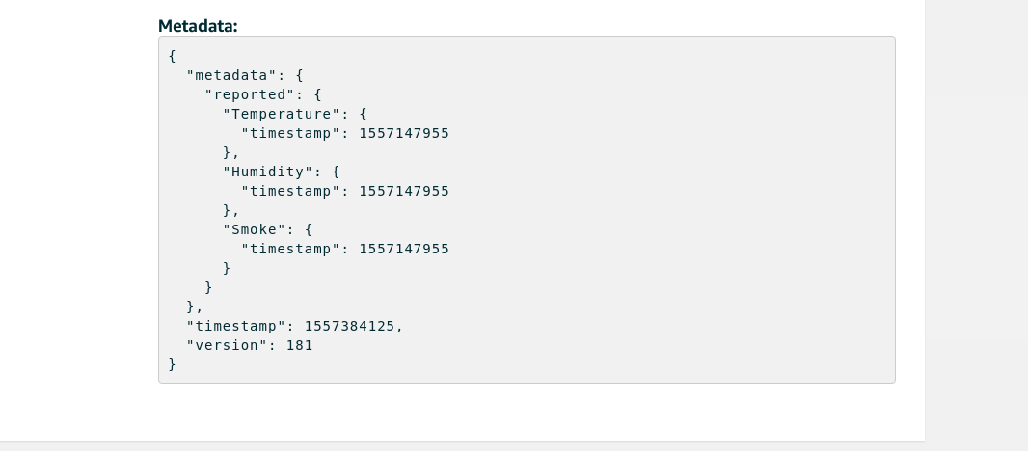

**STEP 22: OUTPUT GRAPH**

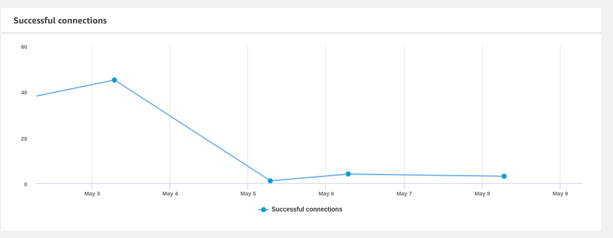

**STEP 23:OUTPUT GRAPH.**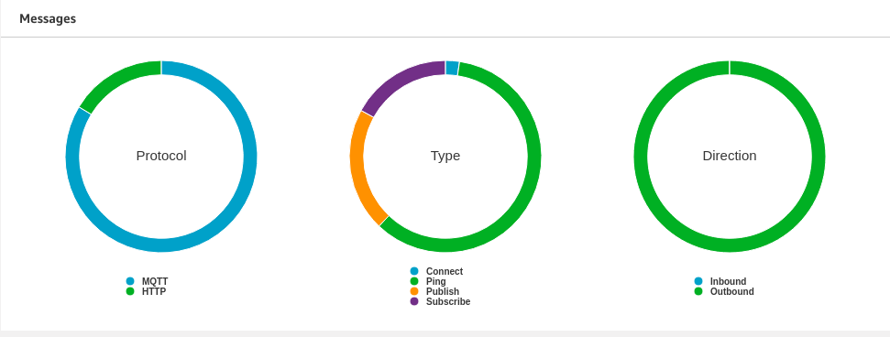

**STEP 24:OUTPUT GRAPH FOR INBOUND AND OUTBOUND.**

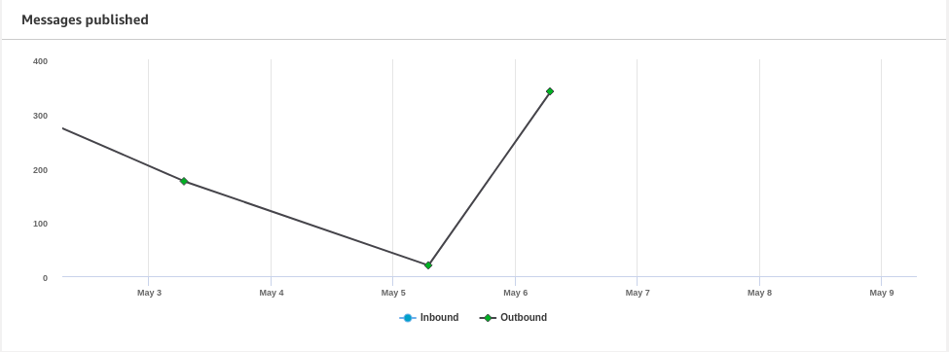

**STEP 25: OUTPUT GRAPH FOR SUCCESS AND FALIURE .**

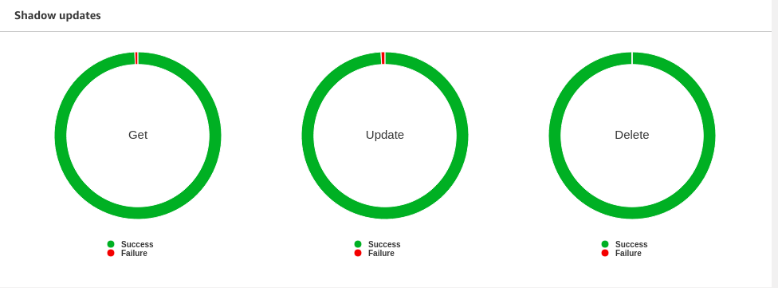

***GOAL 2: SENDING DATA FROM AWS IOT TO DYNMODB DATABASE.***

**STEP 26: GO TO SERVICES AND SELECT DYNAMODB DATABASE.**

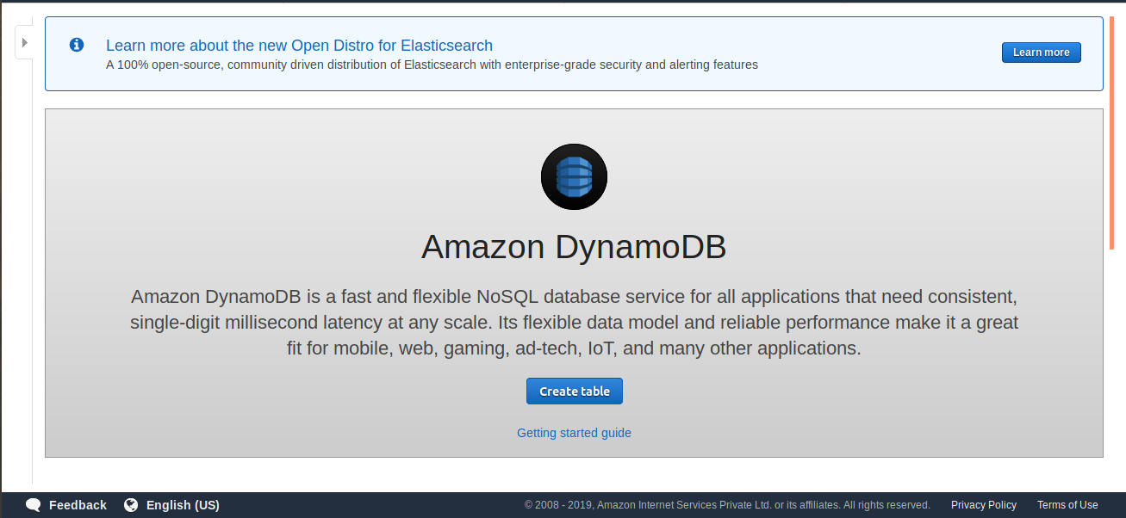

**STEP 27: CREATE A TABLE.**

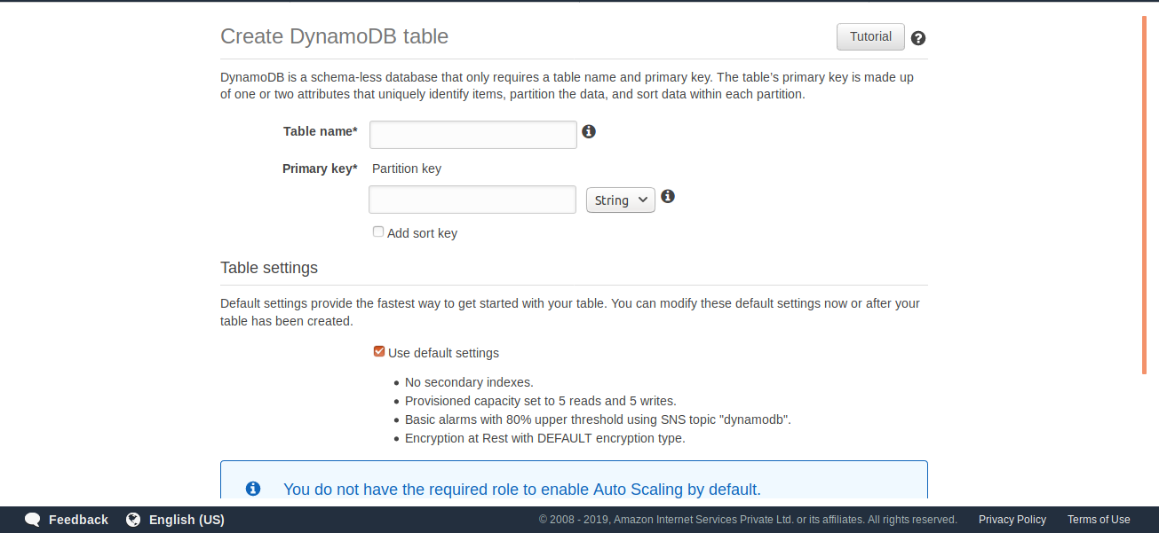

**STEP 28:FILL THE DETAILS FOR TABLE.**

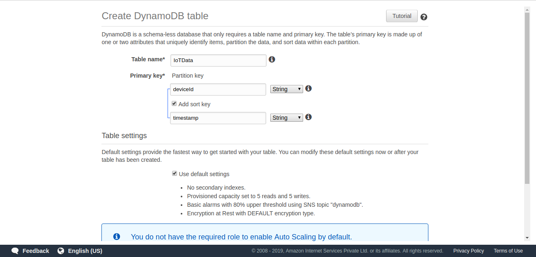

**STEP 29: SELECT CREATE OPTION.**

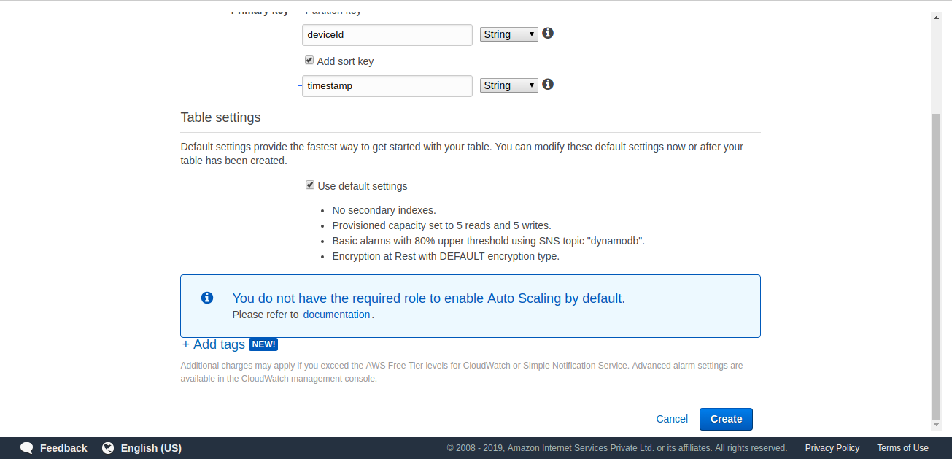

**STEP 30:TABLE IS CREATED.**

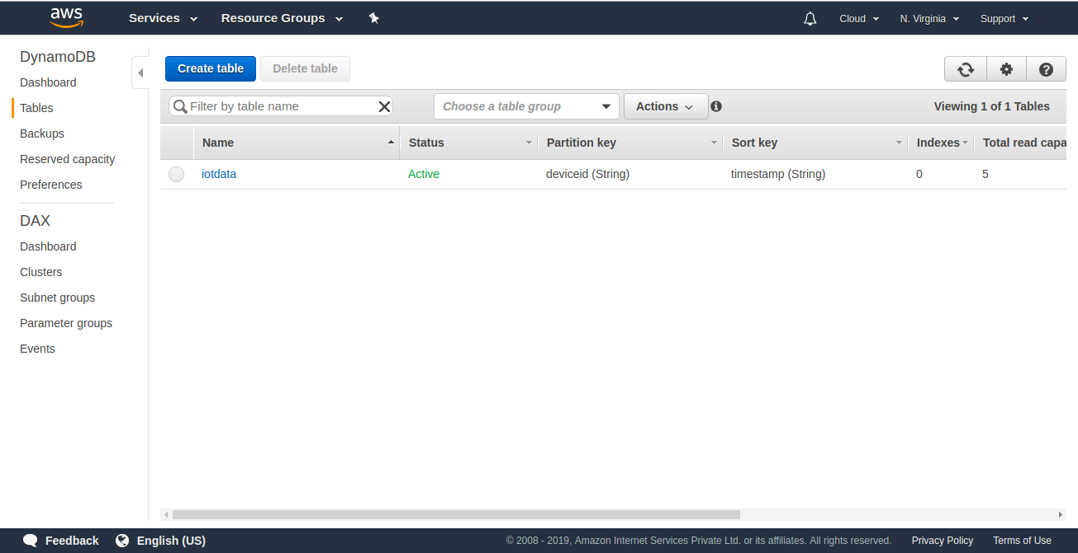

**STEP 31: GO TO OVERVIEW OF TABLE.**

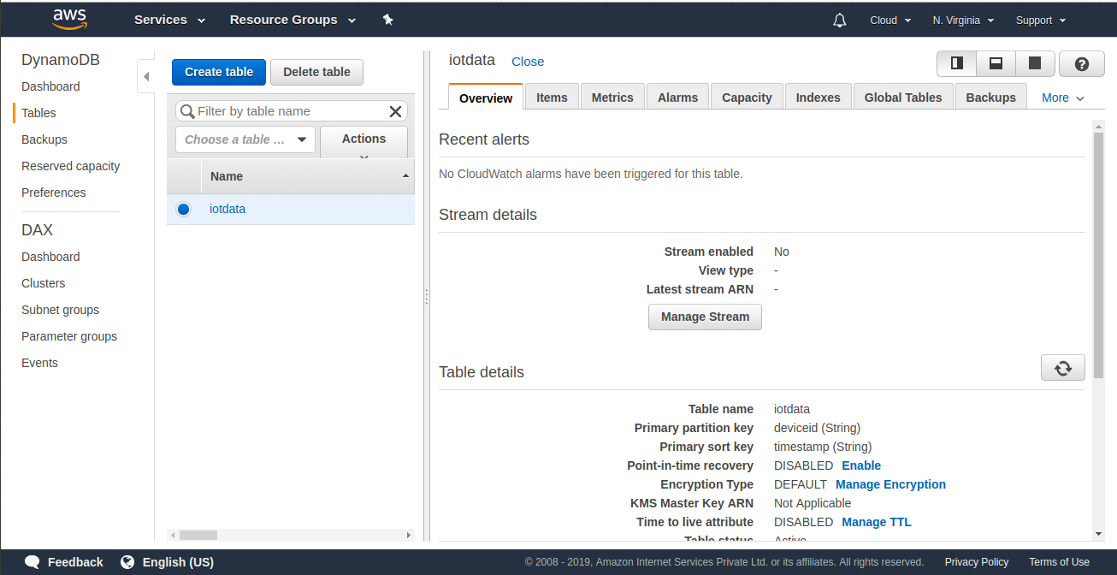

**STEP 32:CREATE AN IOT RULE IN IOT SECTION.**

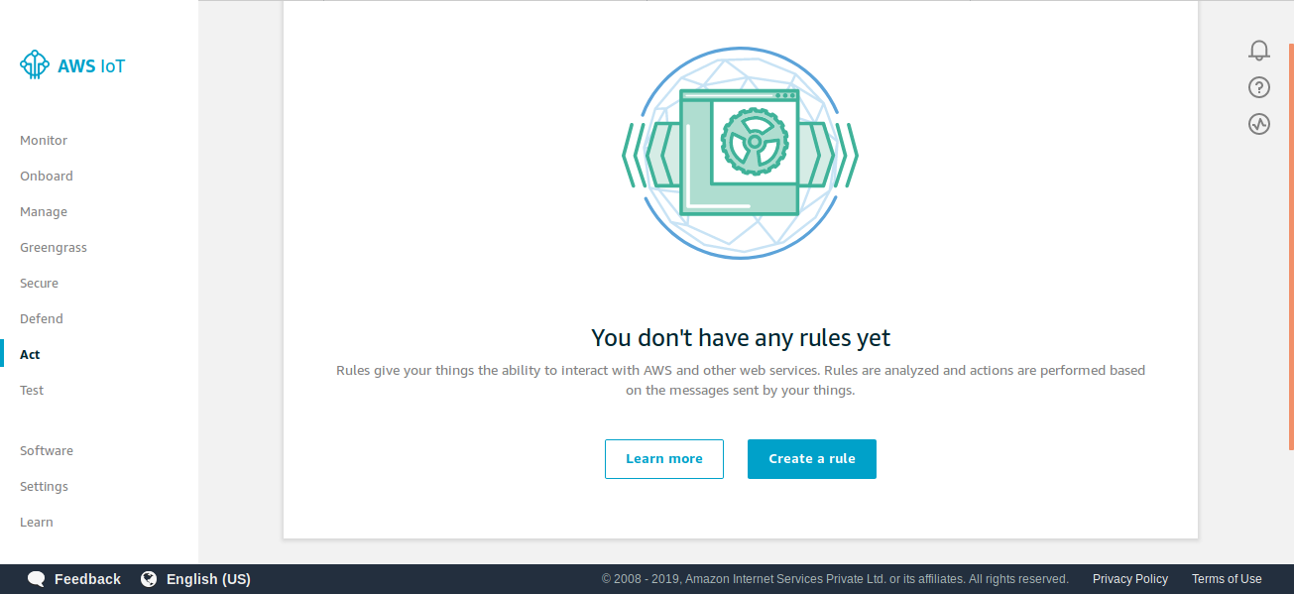

**STEP 33:GIVE NAME AND DESCRIPTION FOR IOT RULE.**

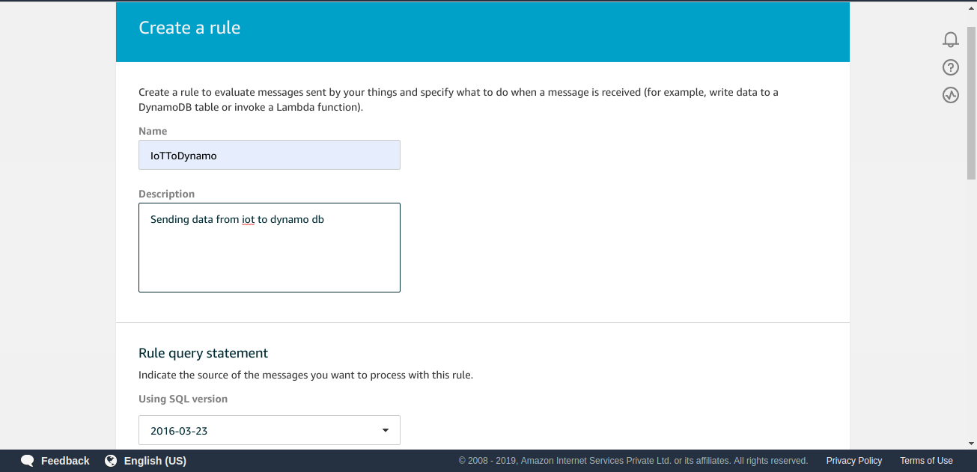

**STEP 34: WRITE THE SQL QUERY FOR THE SAME.**

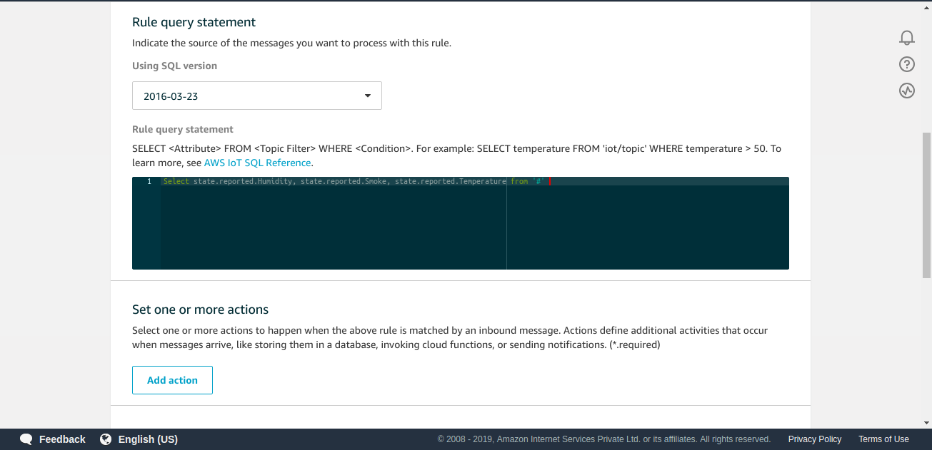

**STEP 35:ADD THE ACTION.**

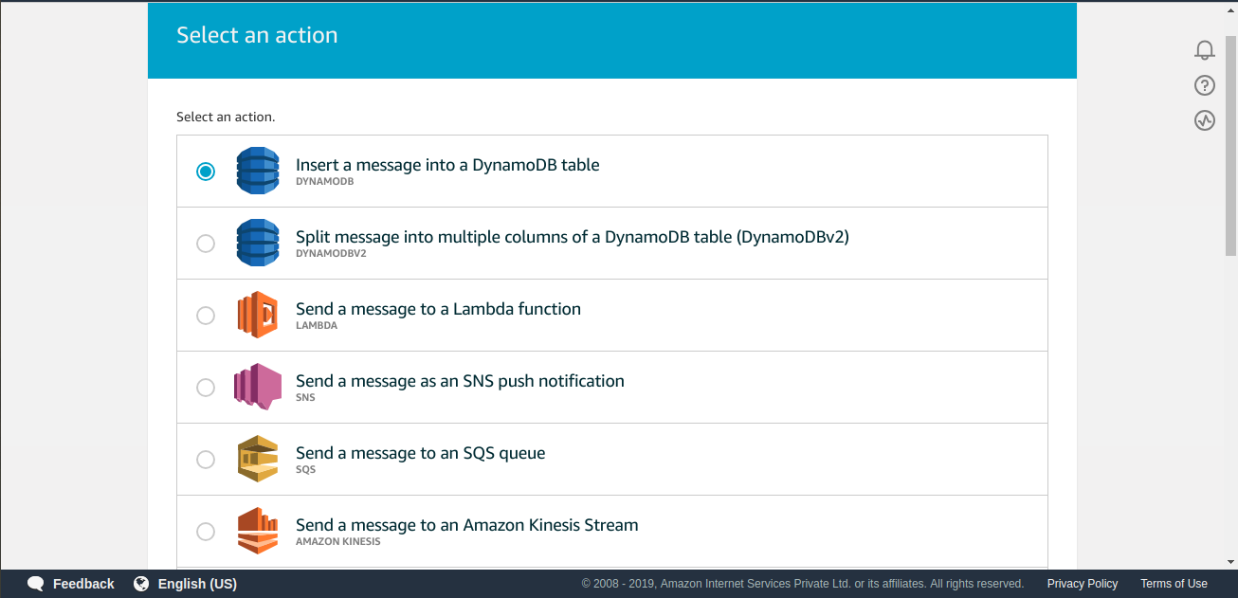

**STEP 36:CONFIGURE THE ACTION.**

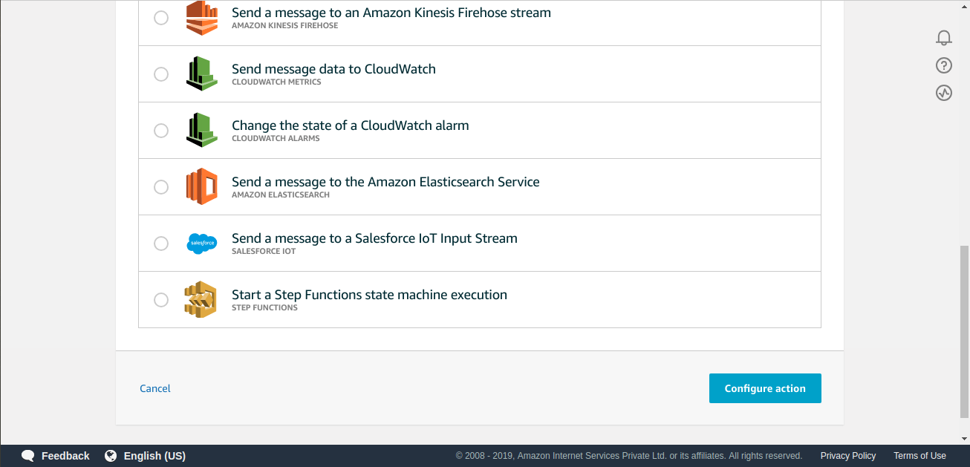

**STEP 37:ACTION HAS BEEN CREATED.**

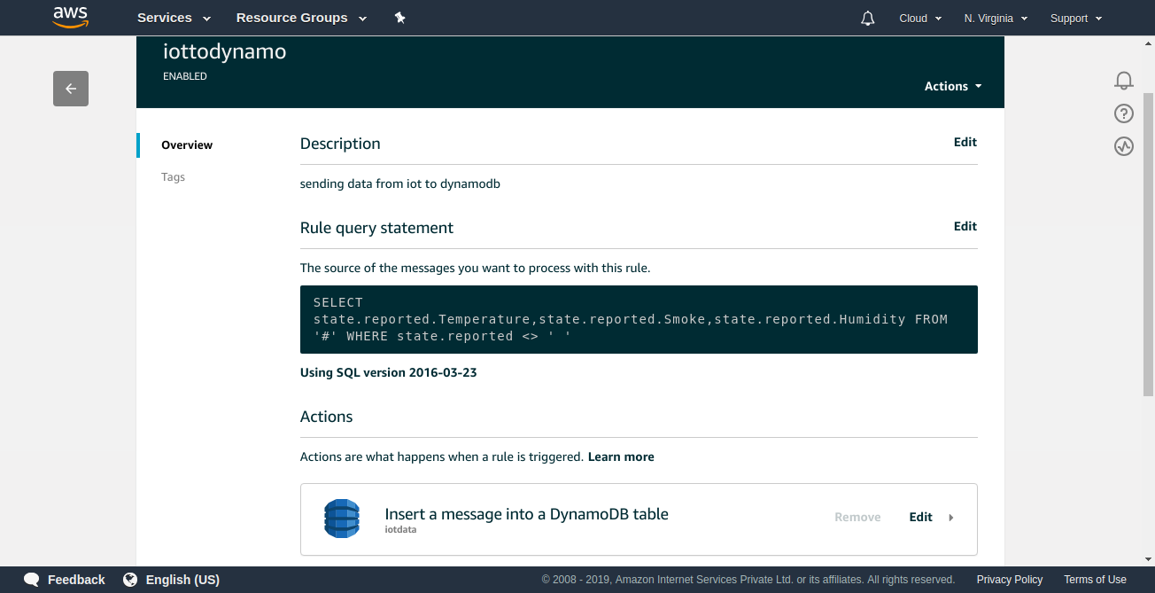

**STEP 38:SELECT TABLE AND GIVE DETAILS.**

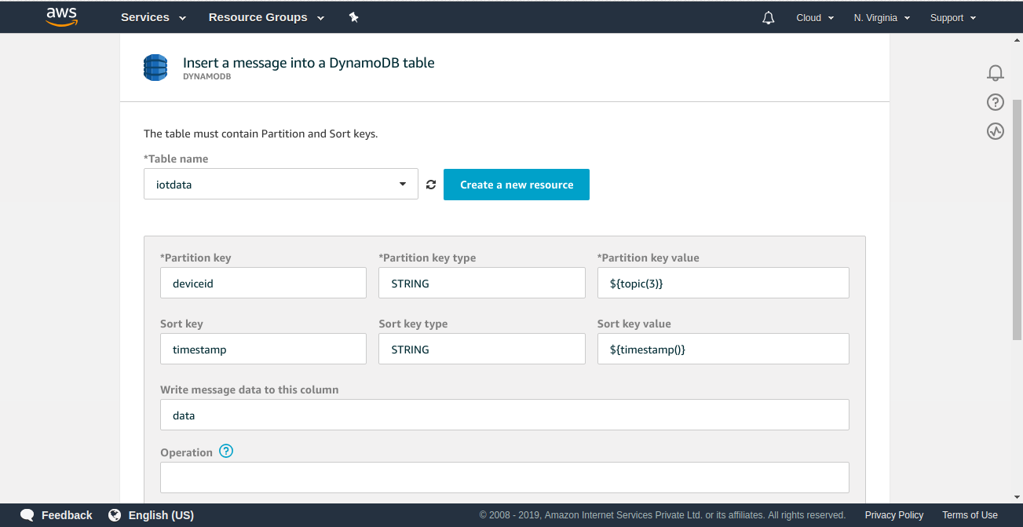

**STEP 39: GO TO UPDATE .**

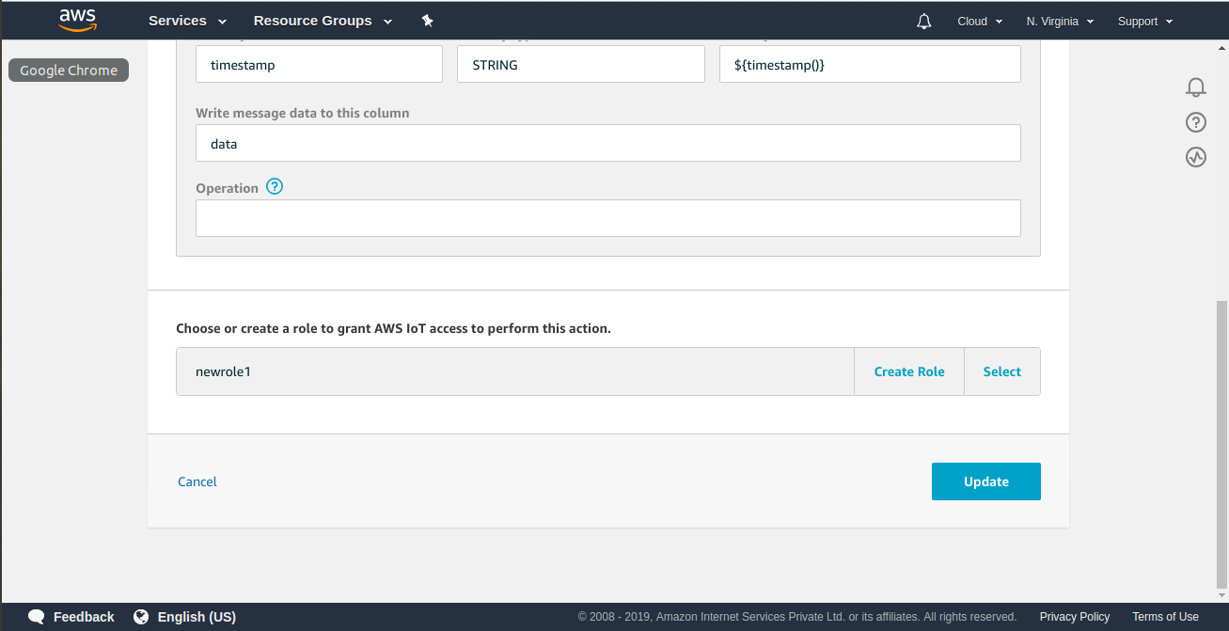

**STEP 40:RULE WILL BE CREATED.**

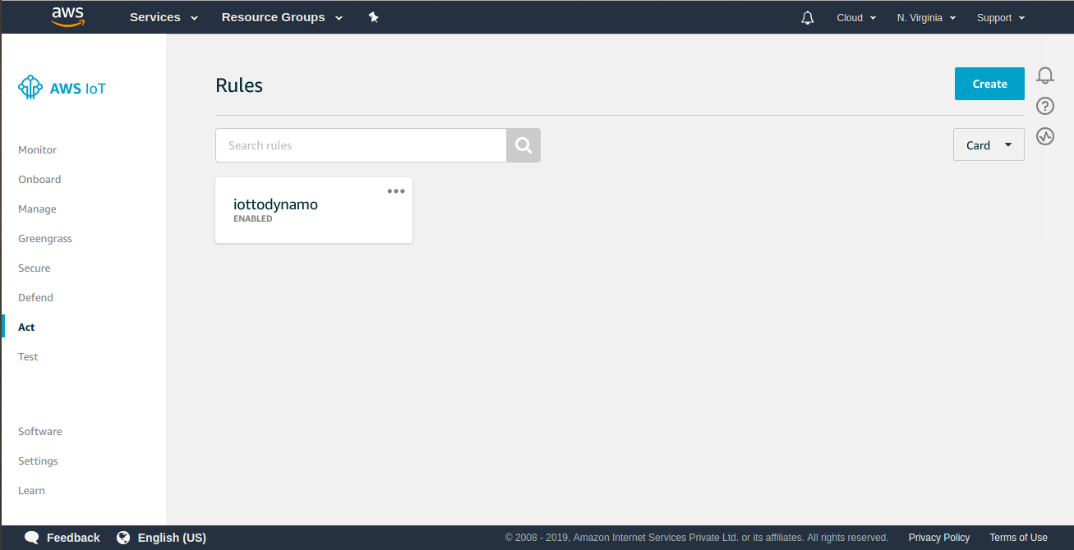

**STEP 41:LOAD THE ARDUINO CODE AND CHECK DATA IN SHADOW STATE.**

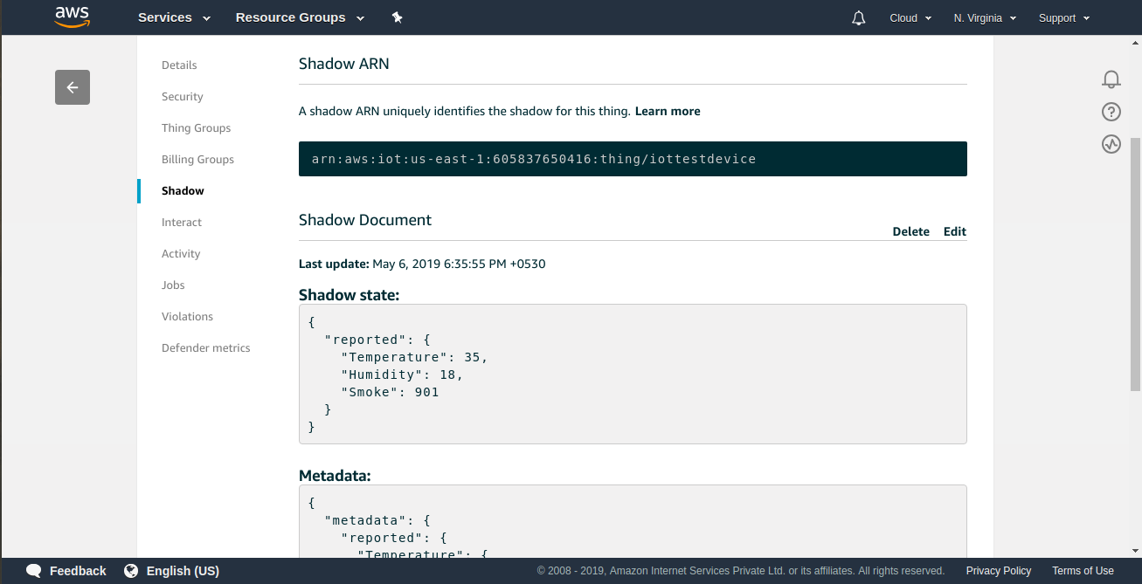

**STEP 42:GO TO DYNAMODB TABLE.**

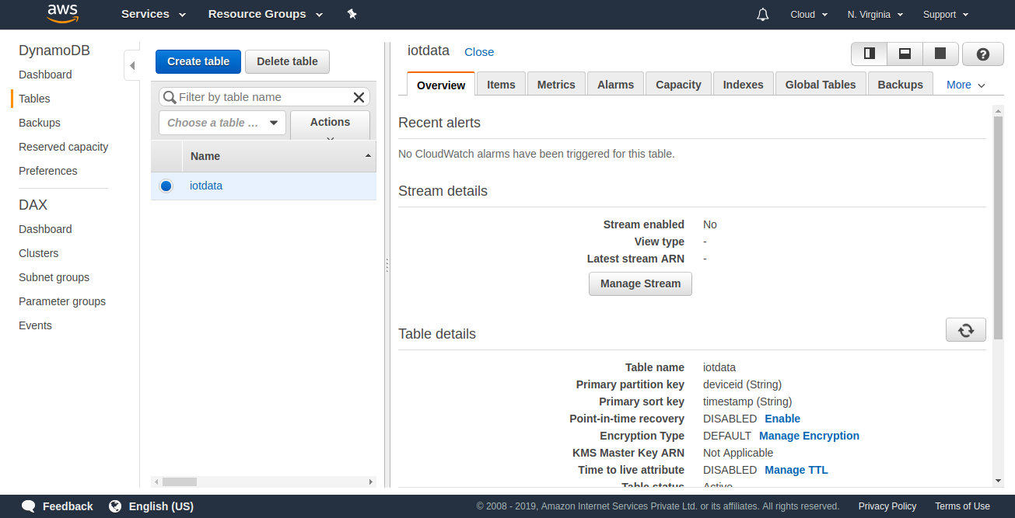

**STEP 43:CHECK THE TABLE.**

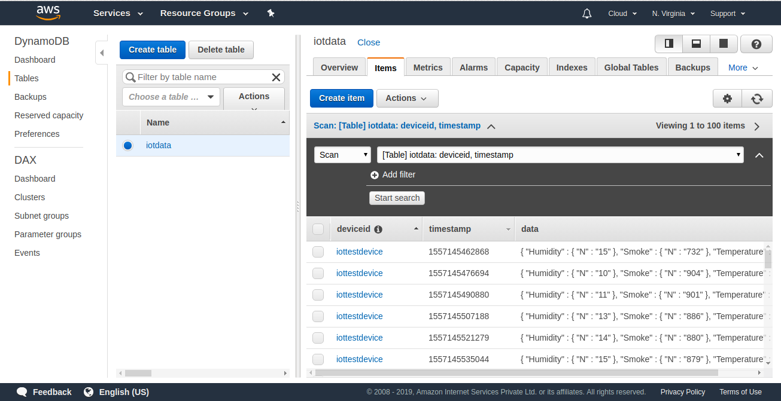

**STEP 44: DATA IS UPDATED IN TABLE IN JSON FORMAT.**

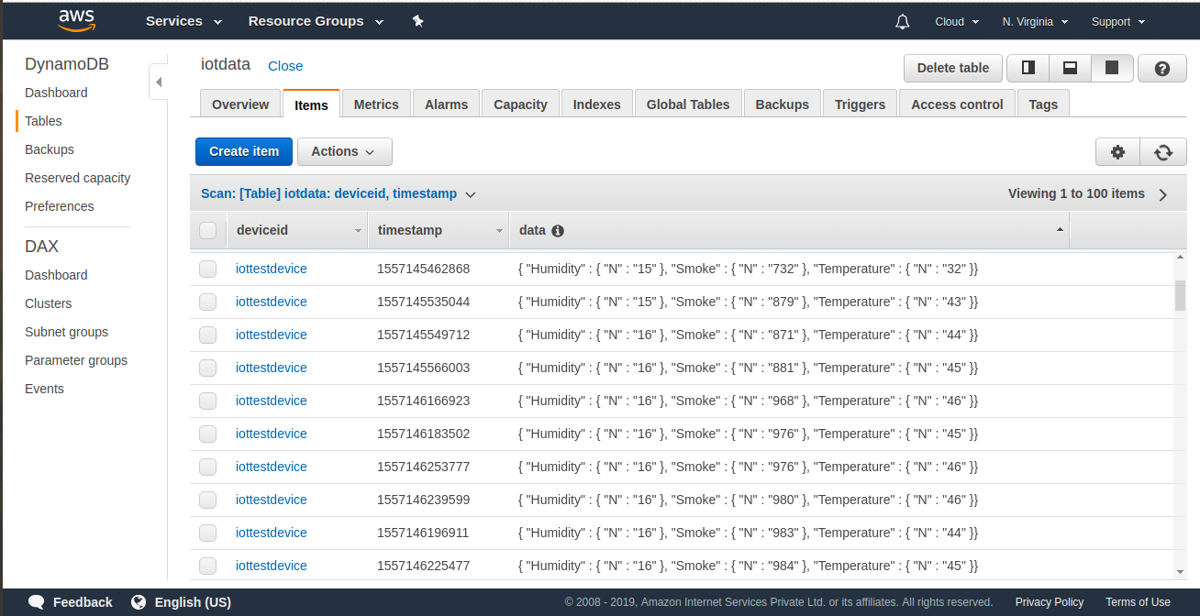

**STEP 45: DATA FORMAT.**

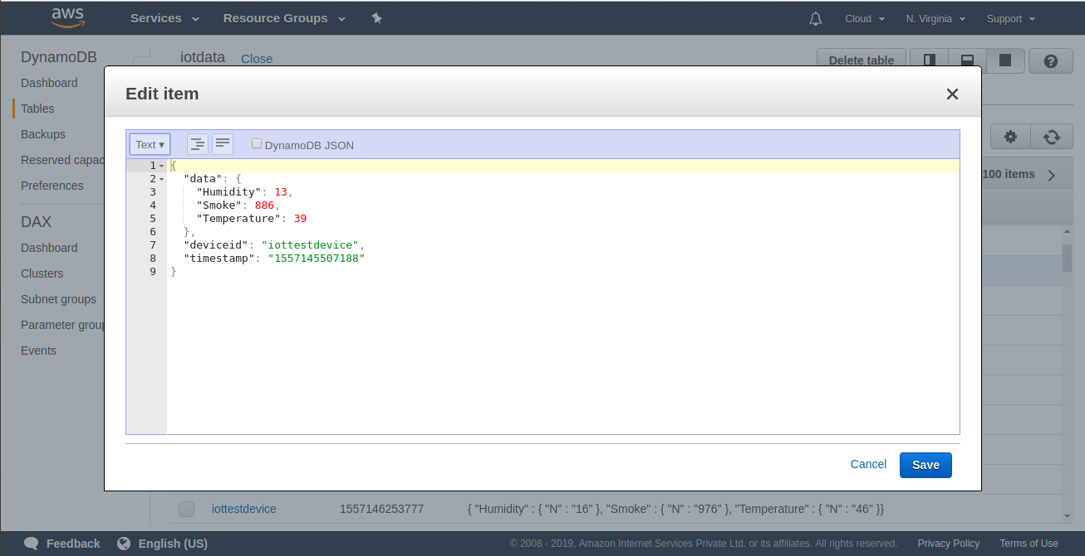

***GOAL 3: MAINTAINING CSV FILE IN***

***S3 BUCKET.***

**STEP 46: CSV FILE OF DATASET.**

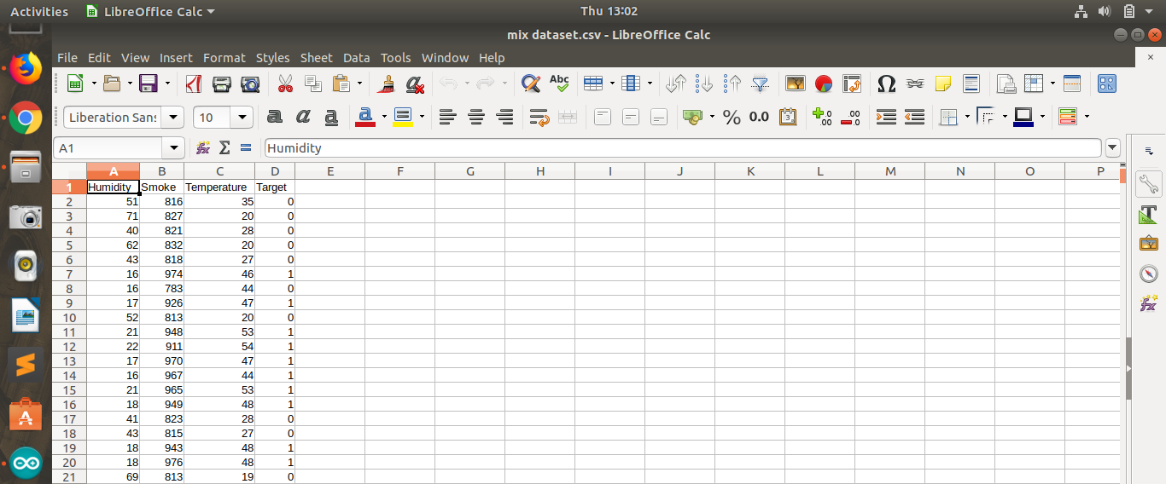

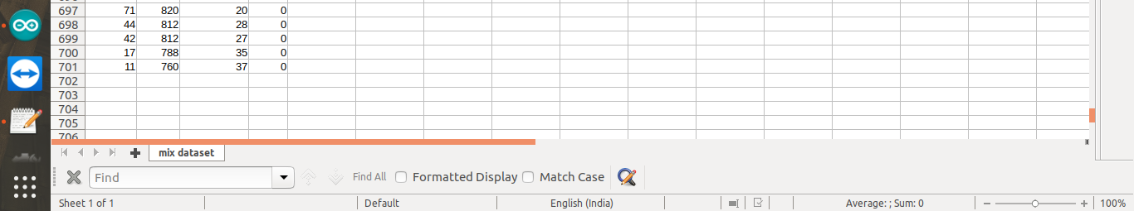

**STEP 47: CREATE A S3 BUCKET AND UPLOAD THE CSV FILE IN S3 BUCKET.**

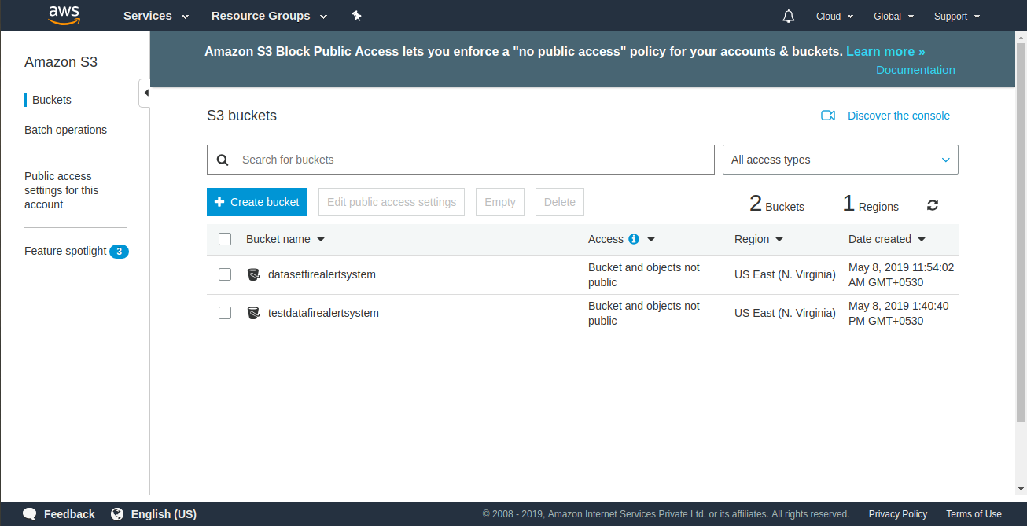

**STEP 48: TRAIN AND VALIDATION DATASET.**

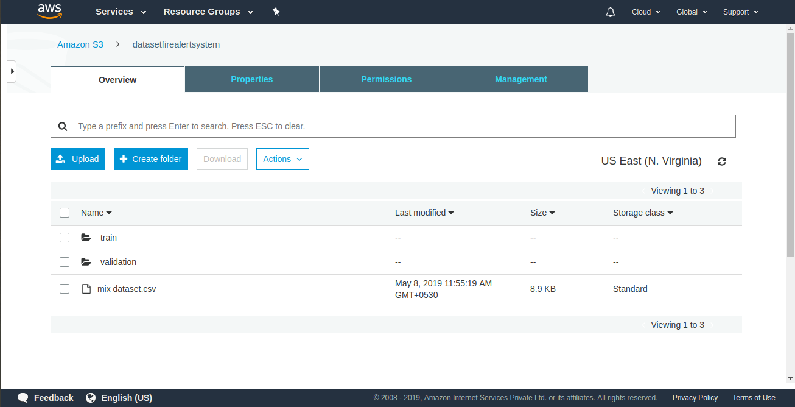

***GOAL 4: APPLYING MACHINE LEARNING ALGO. THROUGH AWS SAGEMAKER.***

**STEP 49: AWS SAGEMAKER.**

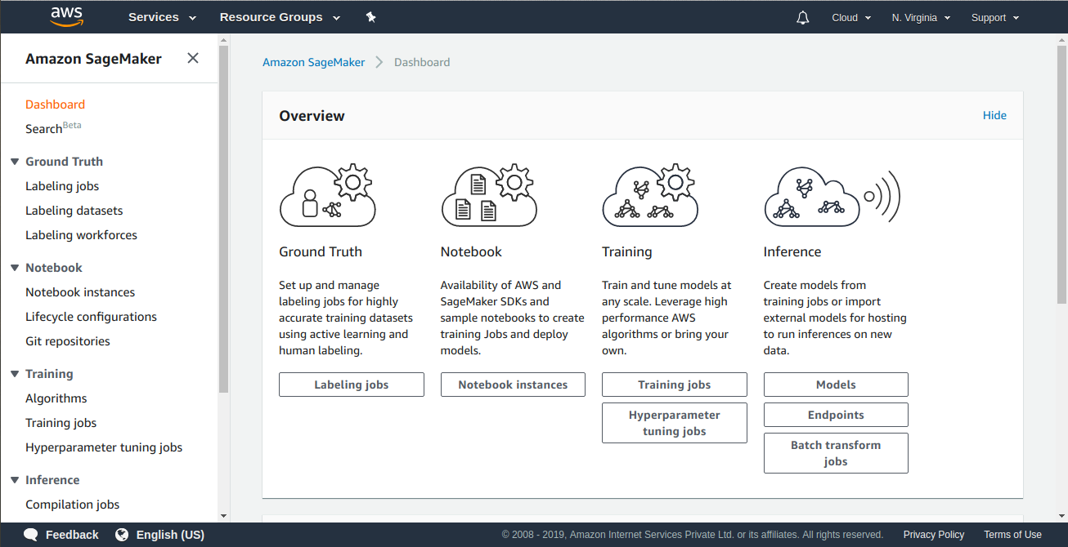**STEP 50: OPEN NOTEBOOK INSTANCES AND SELECT CREATE OPTION .**

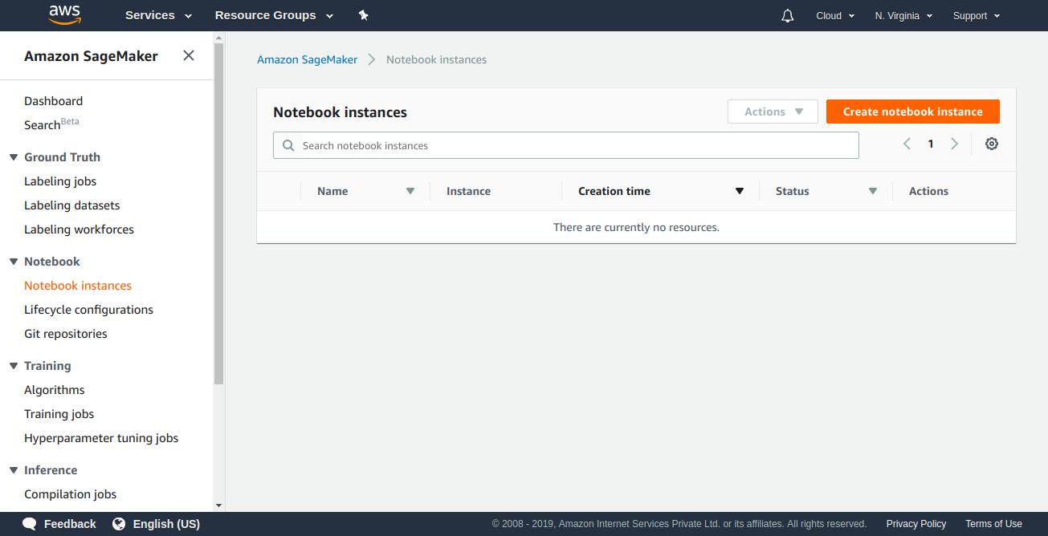

**STEP 51: GIVE THE NAME OF NOTEBOOK INSTANCE.**

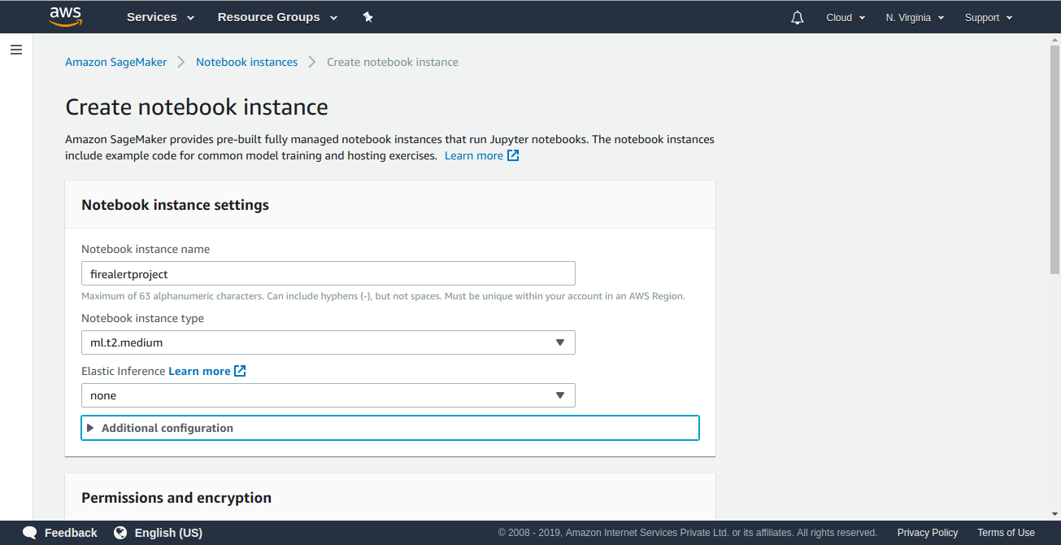**STEP 52: RELATED PERMISSION FOR NOTEBOOK INSTANCE.**

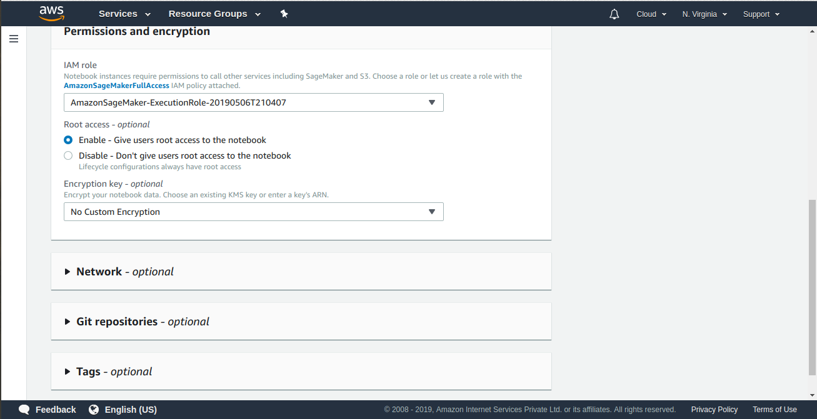

**STEP 53: SELECT CREATE NOTEBOOK INSTANCE.**

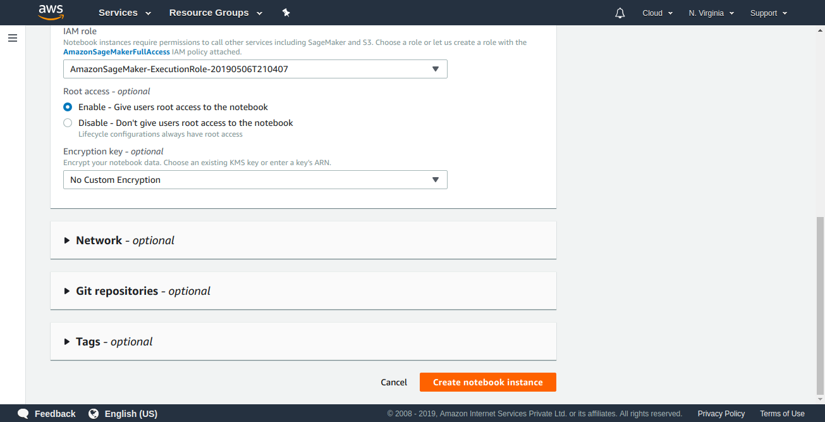**STEP 54:NOTEBOOK INSTANCE IS CREATING.**

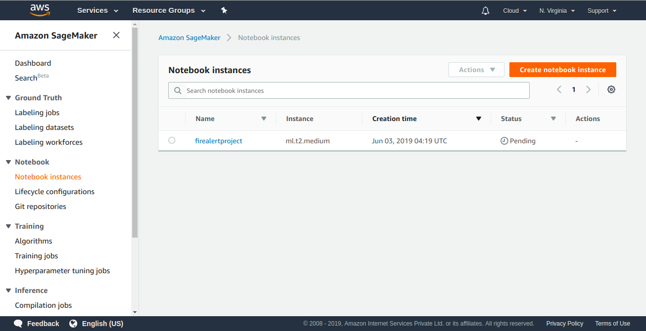

**STEP 55: NOTEBOOK INSTANCE IS CREATED.**

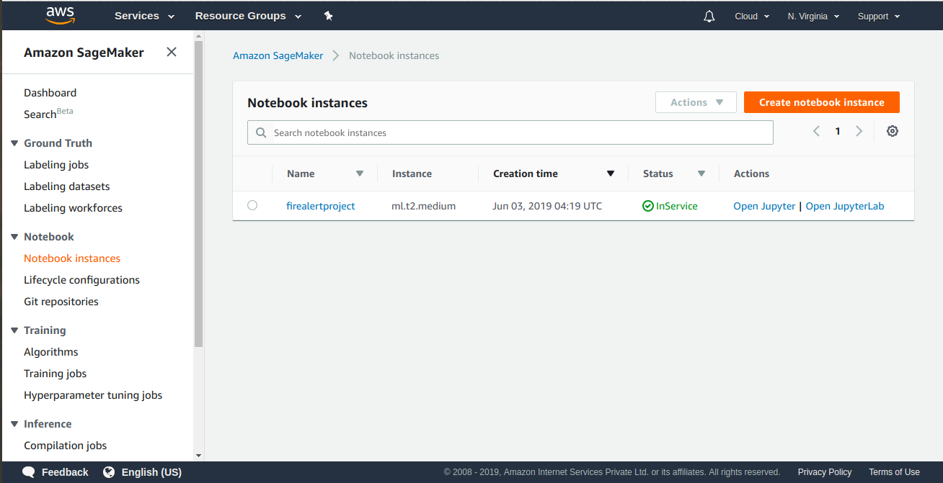**STEP 56: OPEN JUPYTER FOR NOTEBOOK INSTANCE AND OPEN IN CONDA_PYTHON 3.**

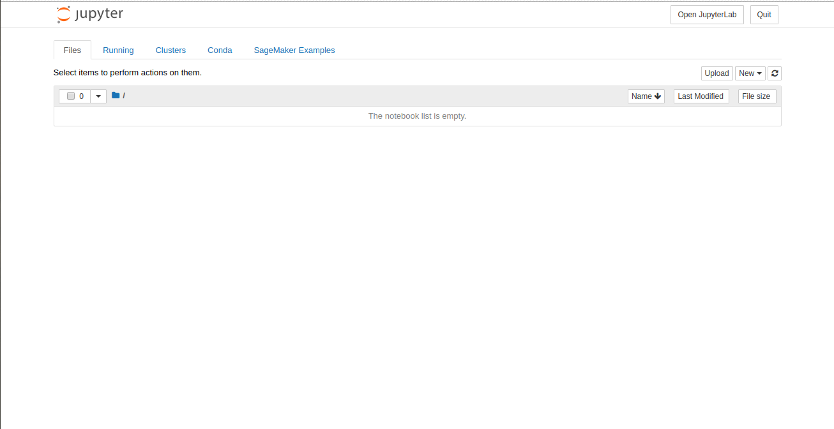

**STEP 57: JUPYTER CONDA_PYTHON IS CREATED.**

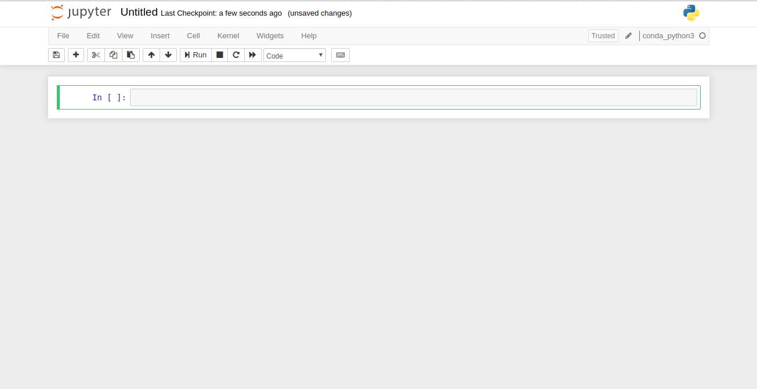**STEP 58: SELECT THE CODE FOR IMPORTING THE LIBRARIES AND RUN IT.**

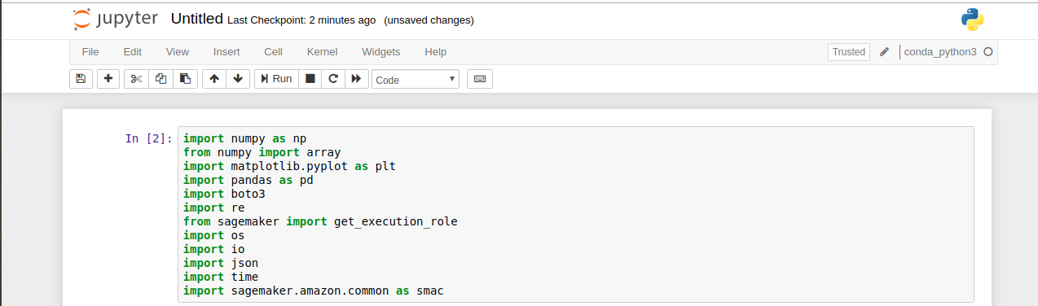**STEP 59: EXPORTING THE DATA AND PRINTING IT.**

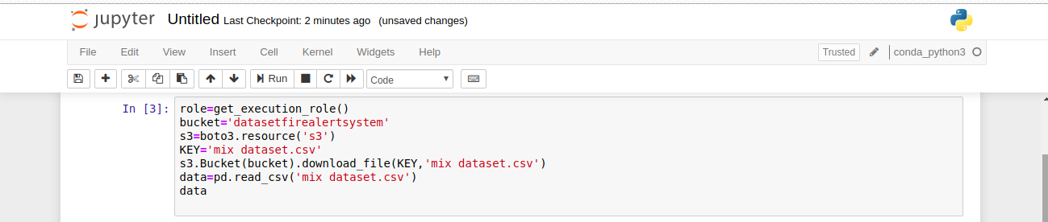

**STEP 60: CSV FILE DATA.**

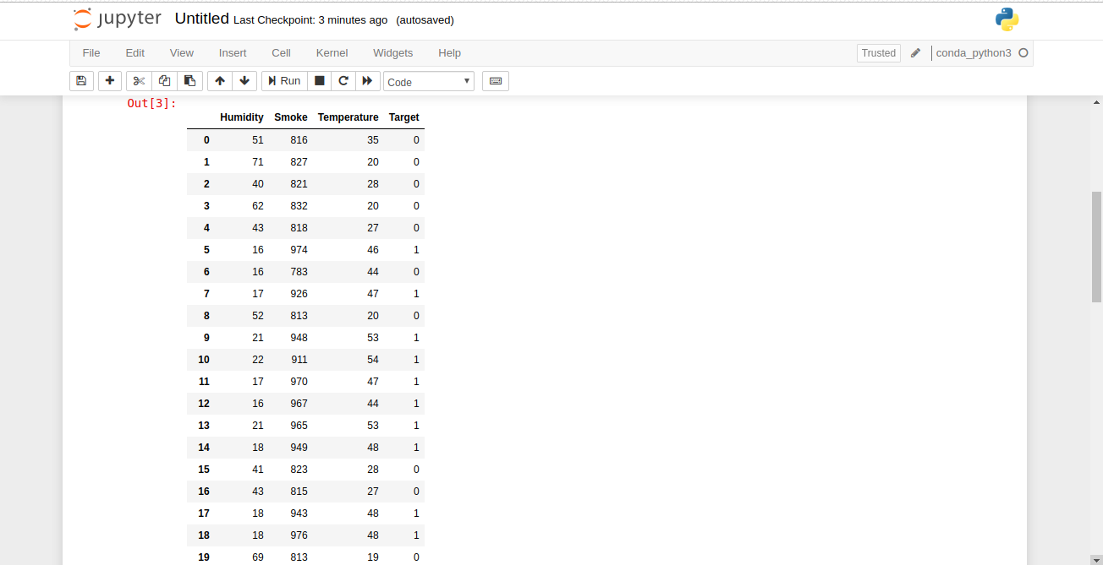**STEP 61: DATASET.**

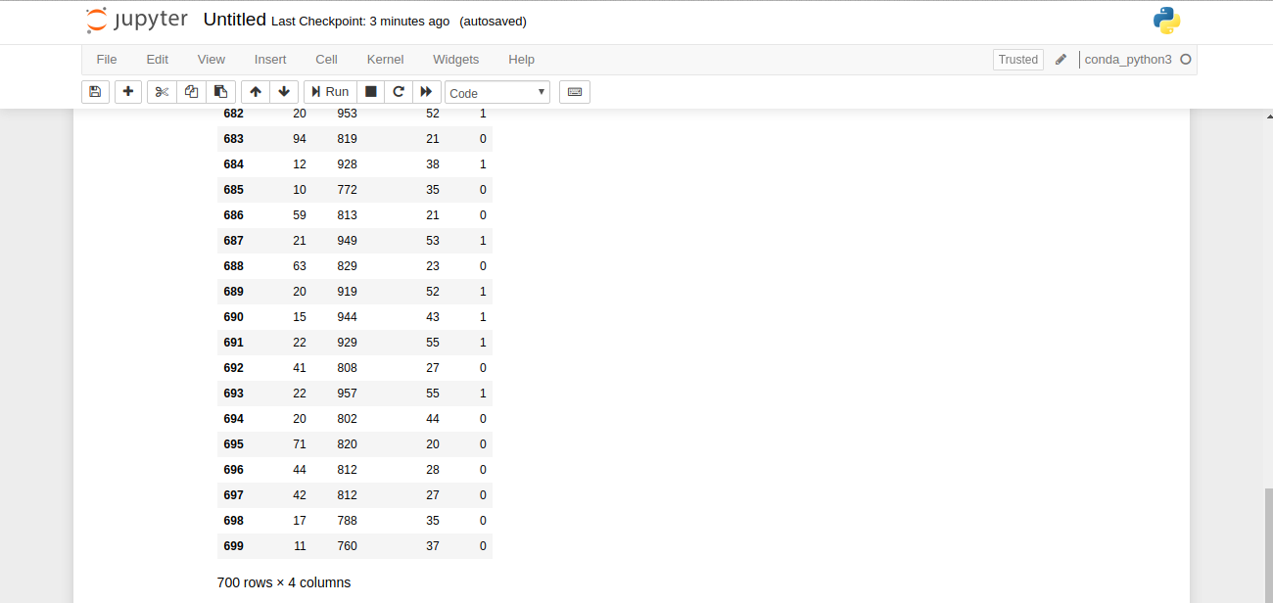

**STEP 62: SPLITING THE TRAINING DATASET.**

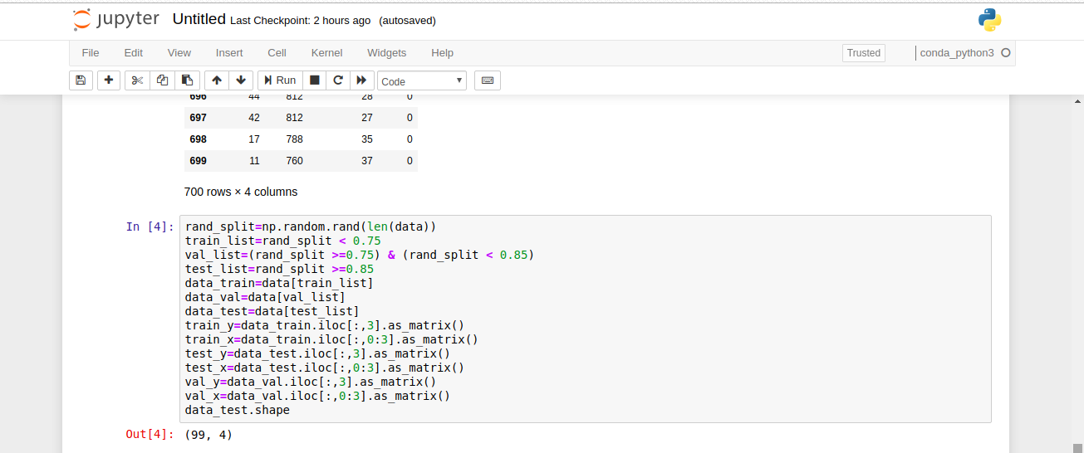**STEP 63: MAINTAINING THE FILE INS3 BUCKET.**

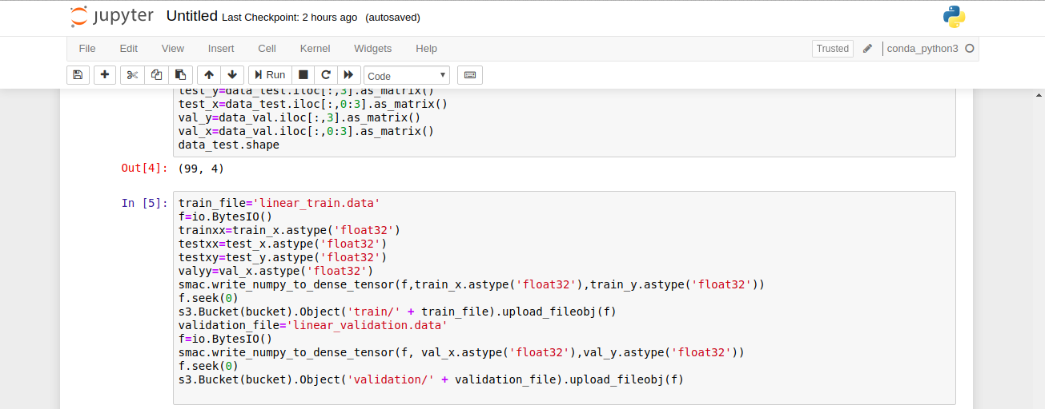

**STEP 64: TRAINING THE DATASET.**

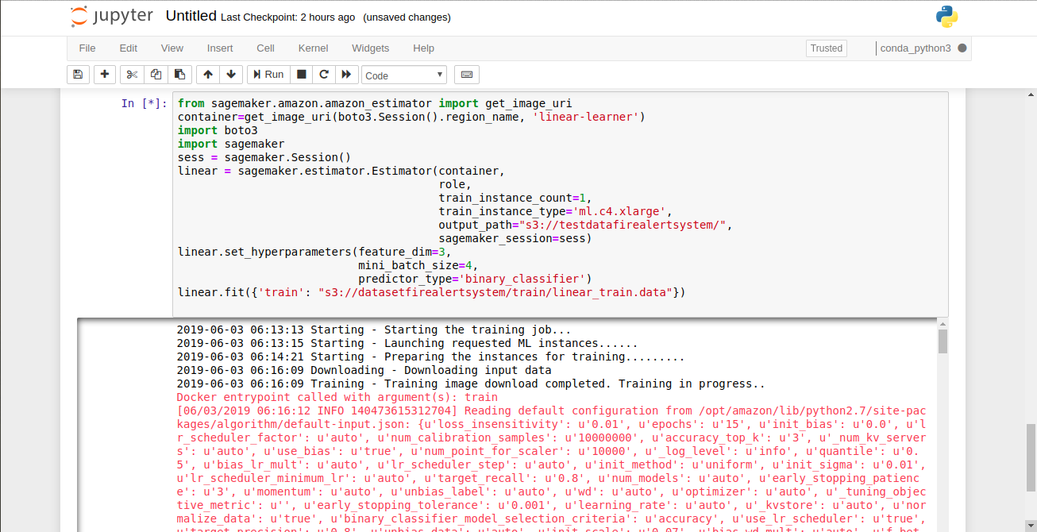

**STEP 65: TRAINING THE JOB COMPLETED.**

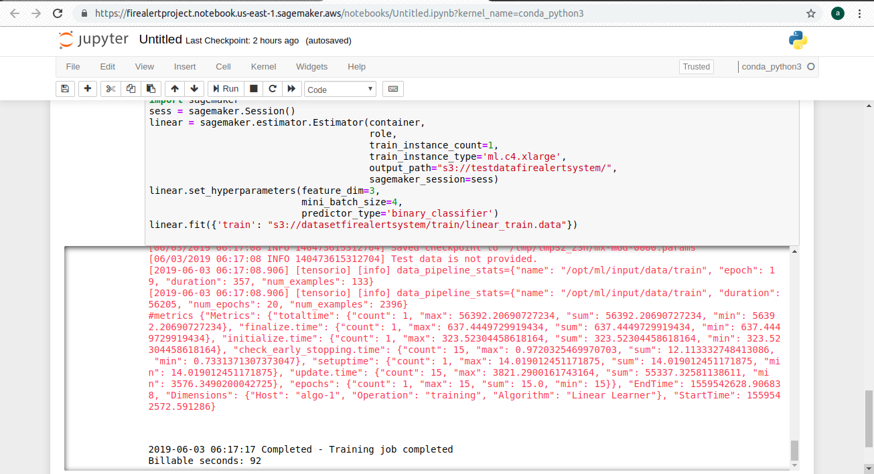

**STEP 66: INTIALIZING THE LINEAR PREDICTOR.**

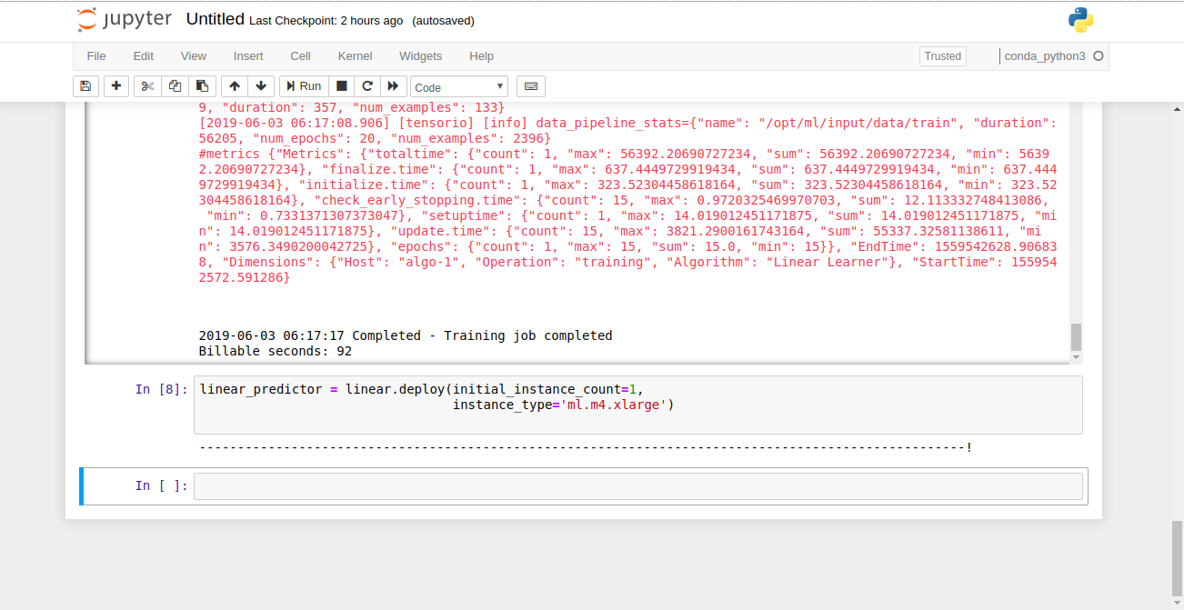**STEP 67: PRINTING THE ACTUAL AND PREDICTED LABEL.**

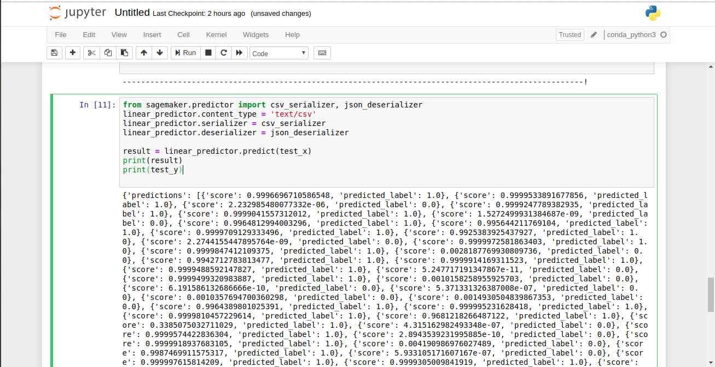

**STEP 68: PRINTING THE ACTUAL AND PREDICTED VALUE.**

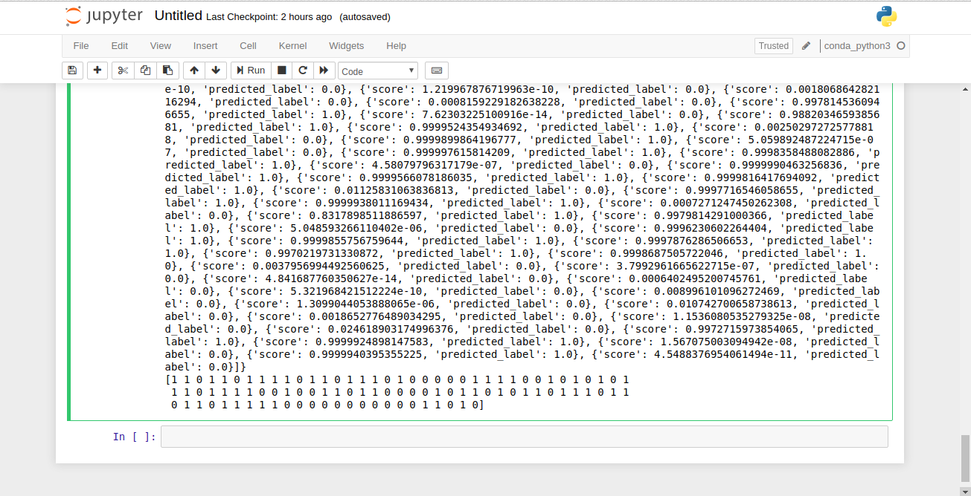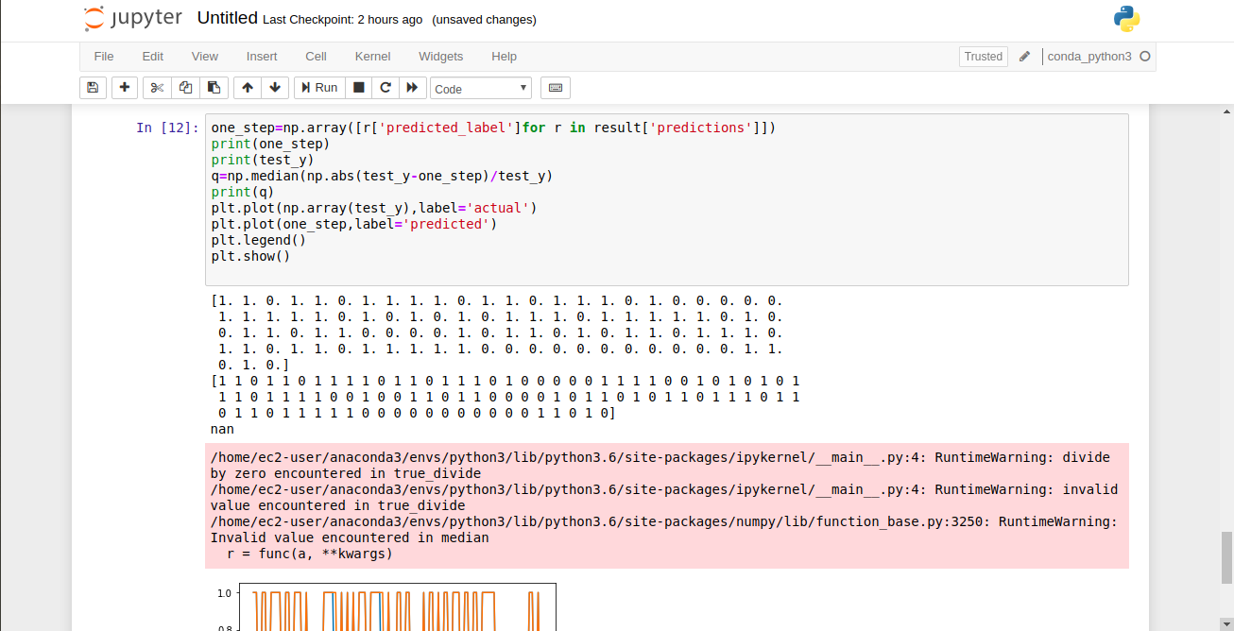**STEP 69: PLOTING THE GRAPH.**

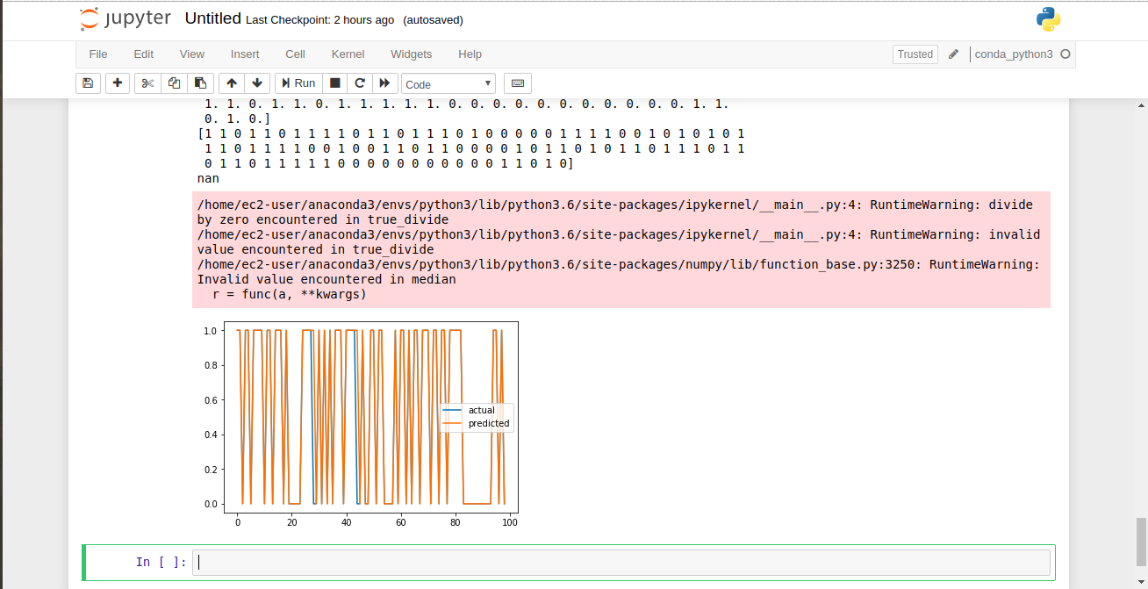

**STEP 70: FINDING THE ACCURACY OF THE MODEL.**

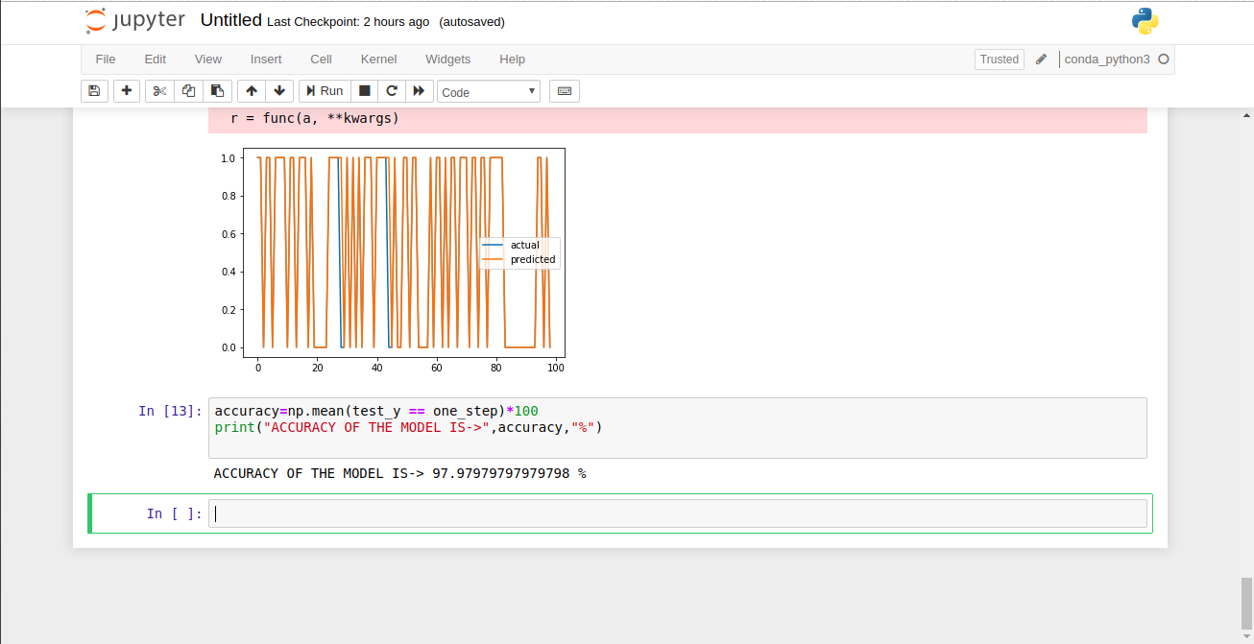

***GOAL 5. ARDUINO CODE.***



